

Anne Arundel County Public Schools | Department of Academics & Strategic Initiatives

Science & Social Studies

|  |  |
| --- | --- |
| **Environmental Impacts**  **Background for Teachers**  Humans change the environment in many ways. Some changes have a positive impact, some negative. These pictures can be sorted as follows: | |
| **Actions** | **Negative Impacts** |
| Cutting down forests | Loss of food and homes for animals, birds, insects |
| Polluting the air (factory and car pictures) | People and other living things breathe dirty air and get sick; even trees can get sick from dirty air |
| Polluting the water | Dumping in storm drains pollutes the water; Fish, people and other living things get sick from polluted water |
| Littering | Litter is ugly. It can harm people and animals. |
| Making too much trash | Have to build more landfills (places to put the trash); this takes away habitat from other living things |
| **Actions** | **Positive Impacts** |
| Installing a nest box | Provides homes for birds |
| Planting trees | Provides food and homes for animals, birds, insects |
| Filling a bird bath | Provides water for birds, insects and other living things |
| Planting a garden | Vegetable gardens feed people, bees, butterflies, and birds  Flower gardens feed bees, butterflies, and birds |
| Cleaning up pet waste | Keeps bad germs off of the land and out of the water |
| Putting up a bird feeder | Provides food for birds |

**Early Childhood – Kindergarten Updated 2/27/2015**

**Resource Theme 4 1**



**Positive Impacts:**

* **Provides food, water or shelter for other living things**
* **Keeps the earth clean**
* **Keeps people and other living things safe and healthy**

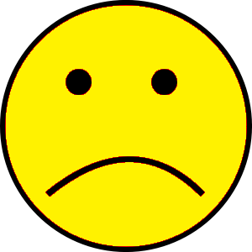**Negative Impacts:**

* **Takes away food, water or shelter from other living things**
* **Makes the earth dirty**
* **Causes sickness or injury to people or other living things**

polluting the air

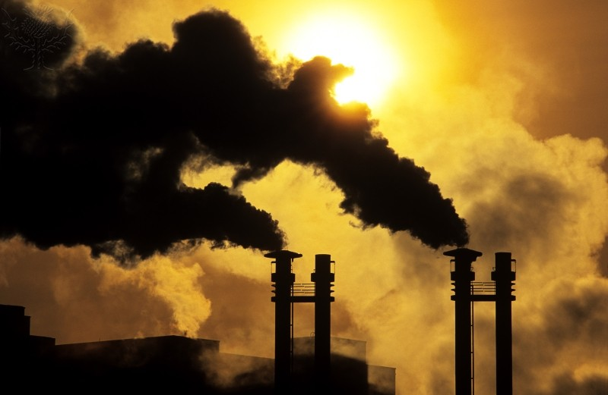

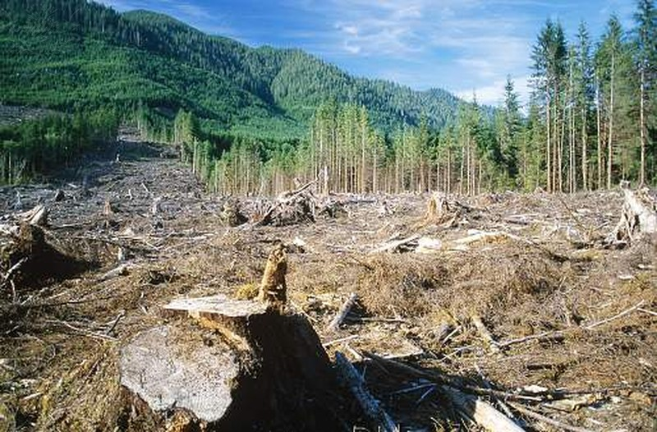

cutting down forests

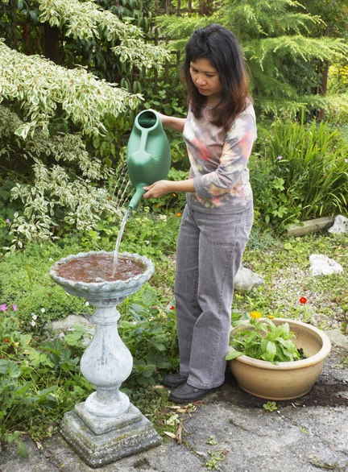

filling a bird bath

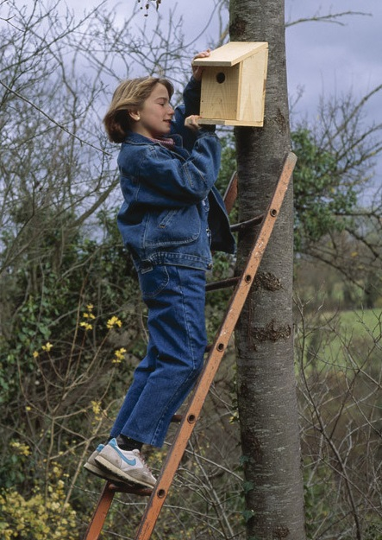

putting up a nest box

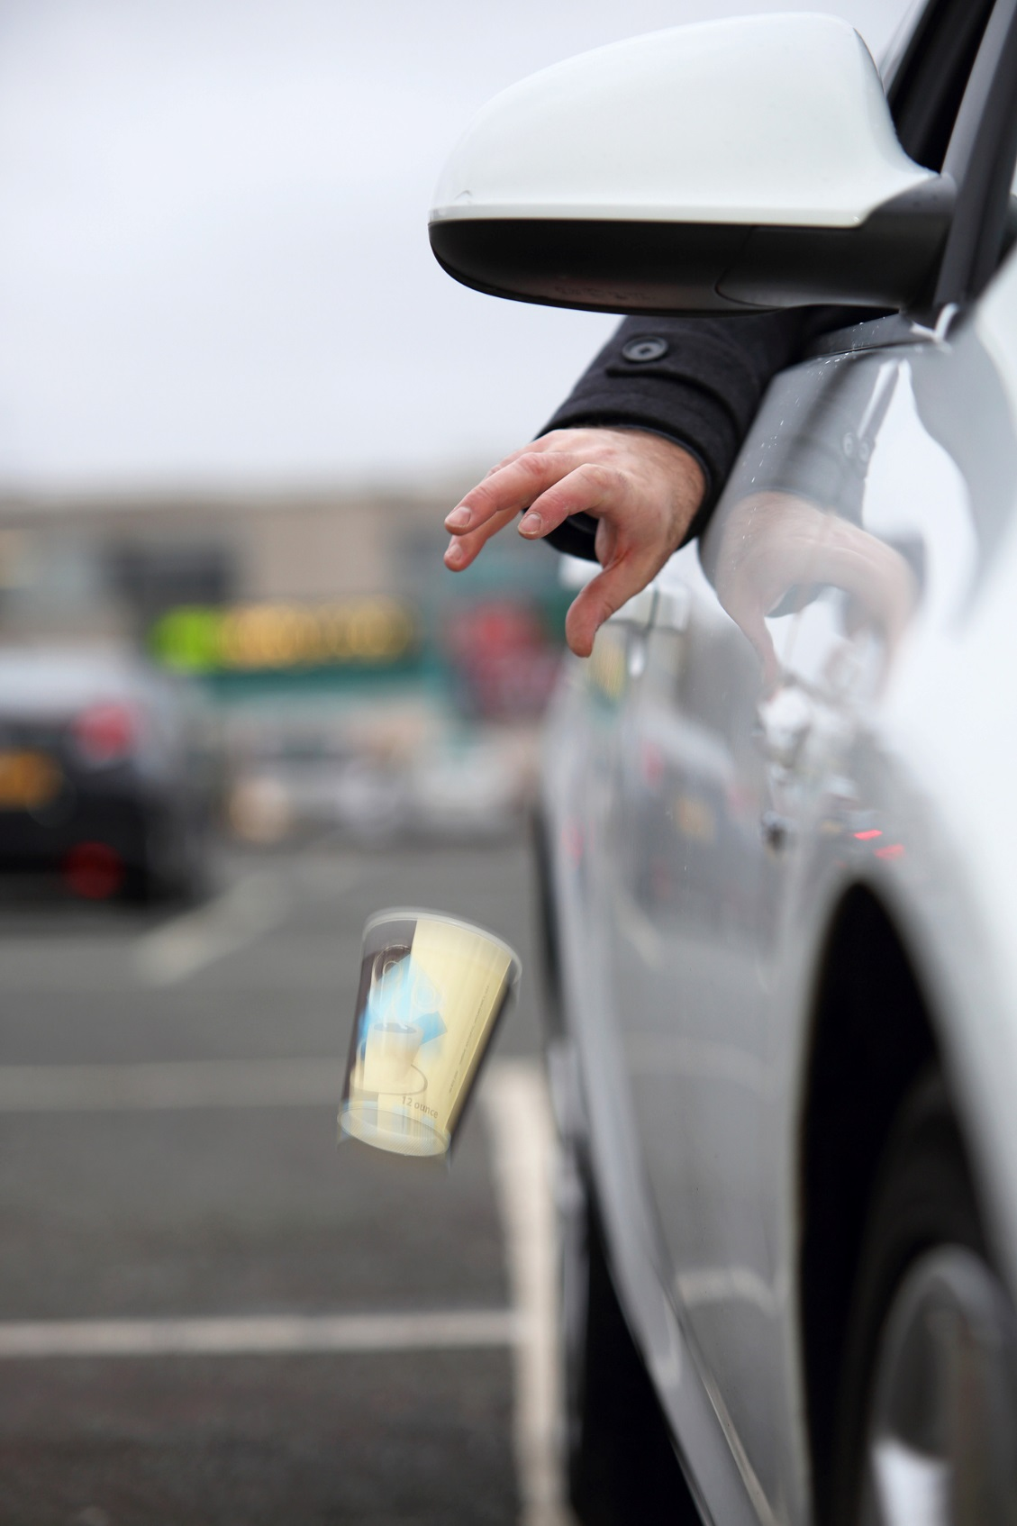

https://www.flickr.com/photos/highwaysagency/8448098769/

littering

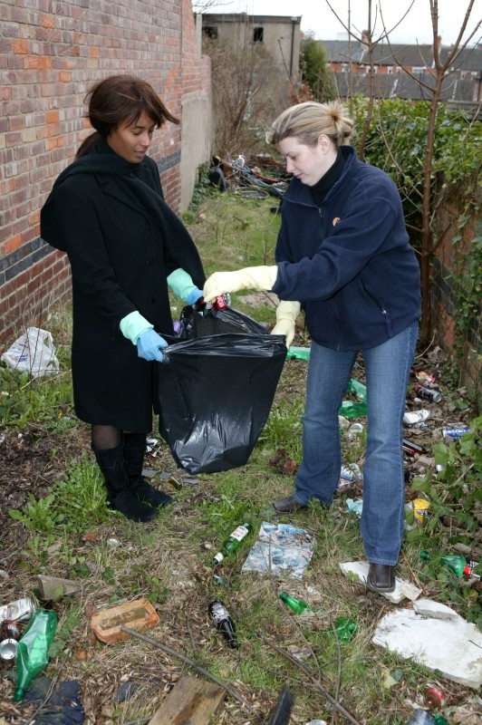

picking up litter

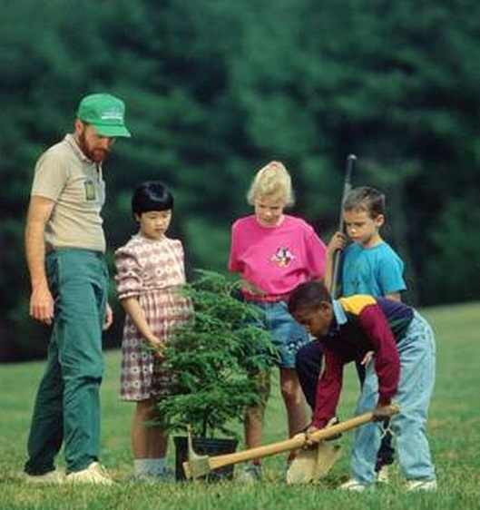

planting a tree

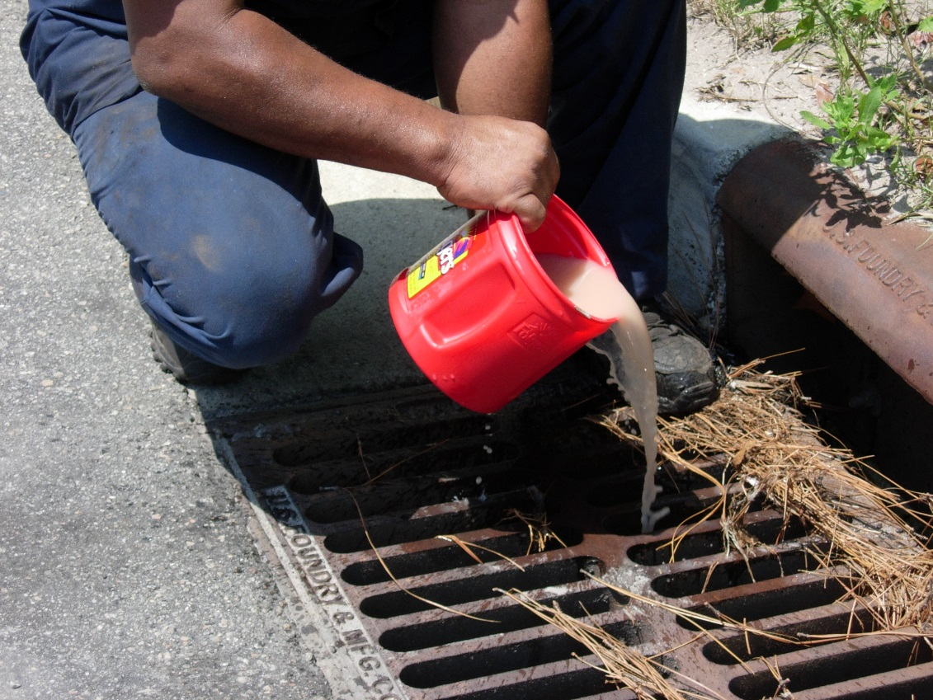

Epa.gov

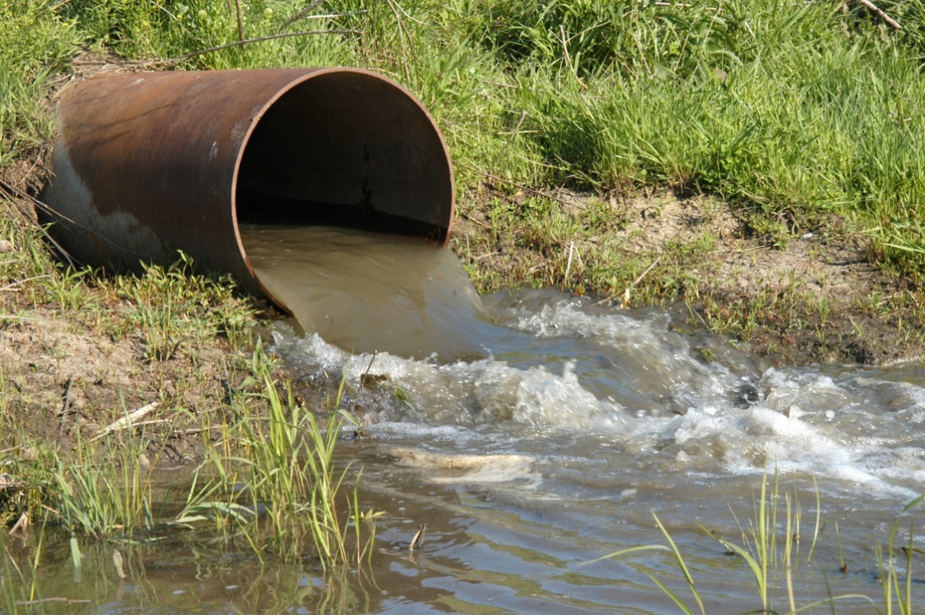

polluting the water

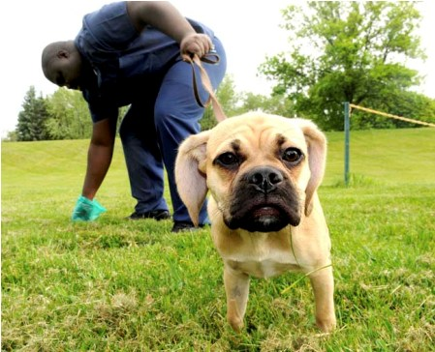

cleaning up pet waste

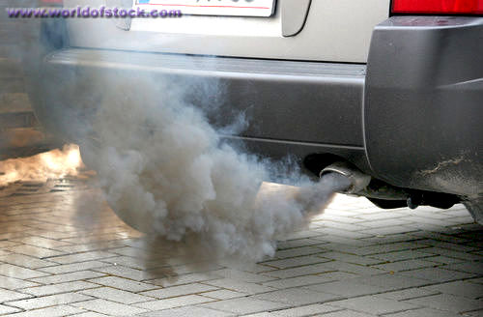

polluting the air

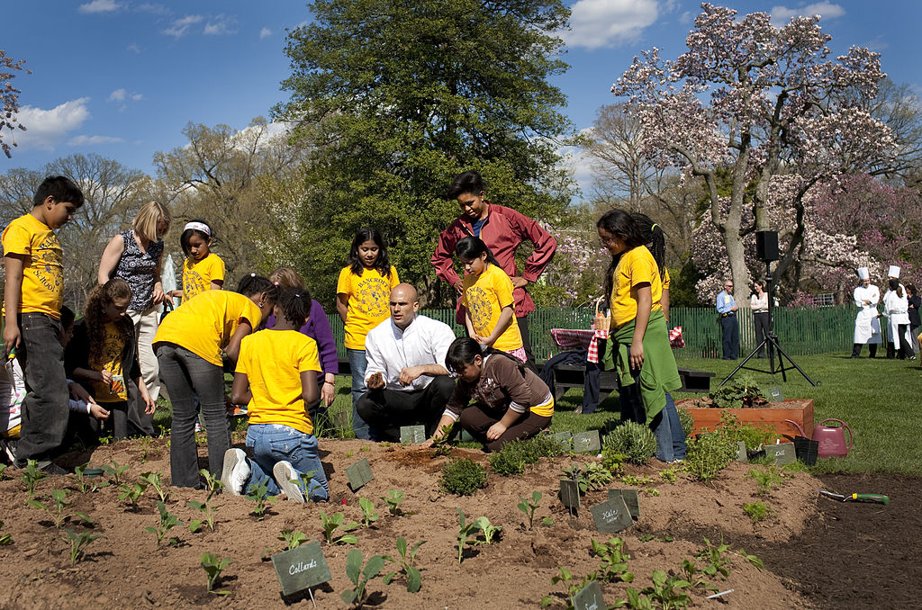

planting a garden

making too much trash

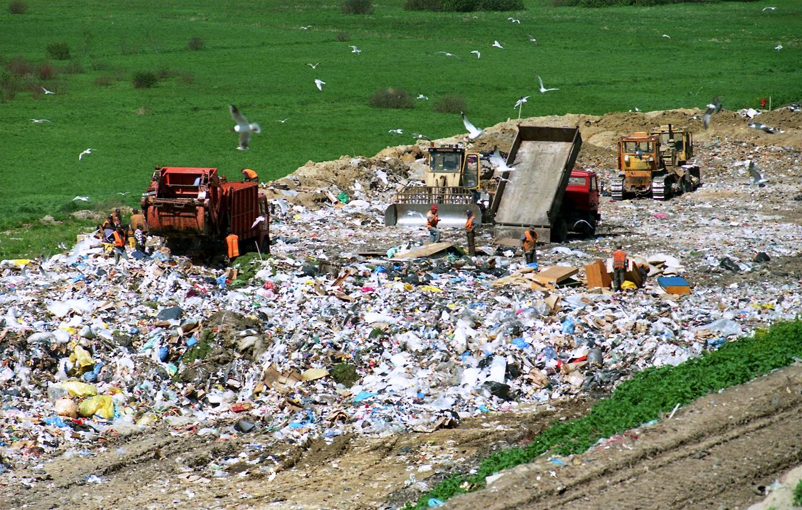

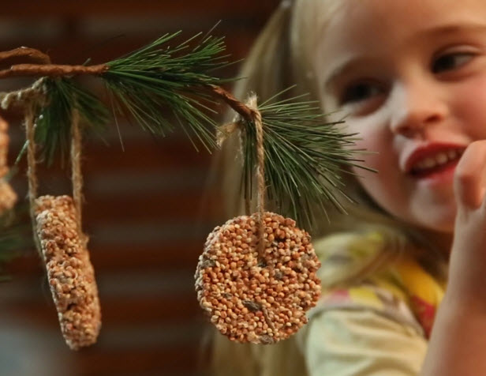

putting a bird feeder outside