Books on QR Codes for the unit of Neighborhoods and Communities



Wilfrid Gordon McDonald Partridge

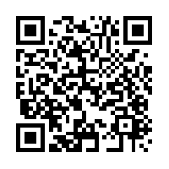

Thank you,

Mr. Falker



Chester’s Way



The Night I Followed the Dog