Books on QR Codes for the unit of Express Yourself

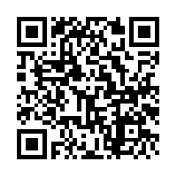

I need my monster

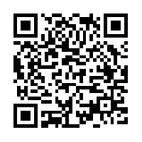

Sophie’s Masterpiece

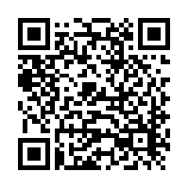

When Pigasso met Mootisse

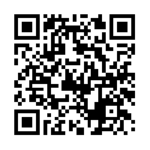

The Kiss That Missed