**"I Love the Look of Words"  
Maya Angelou ©1993**

**Popcorn leaps, popping from the floor  
of a hot black skillet  
and into my mouth.  
Black words leap,  
snapping from the white  
page. Rushing into my eyes. Sliding  
into my brain which gobbles them  
the way my tongue and teeth  
chomp the buttered popcorn.**

**When I have stopped reading,  
ideas from the words stay stuck  
in my mind, like the sweet  
smell of butter perfuming my  
fingers long after the popcorn  
is finished.**

**I love the book and the look of words  
the weight of ideas that popped into my mind  
I love the tracks  
of new thinking in my mind.**

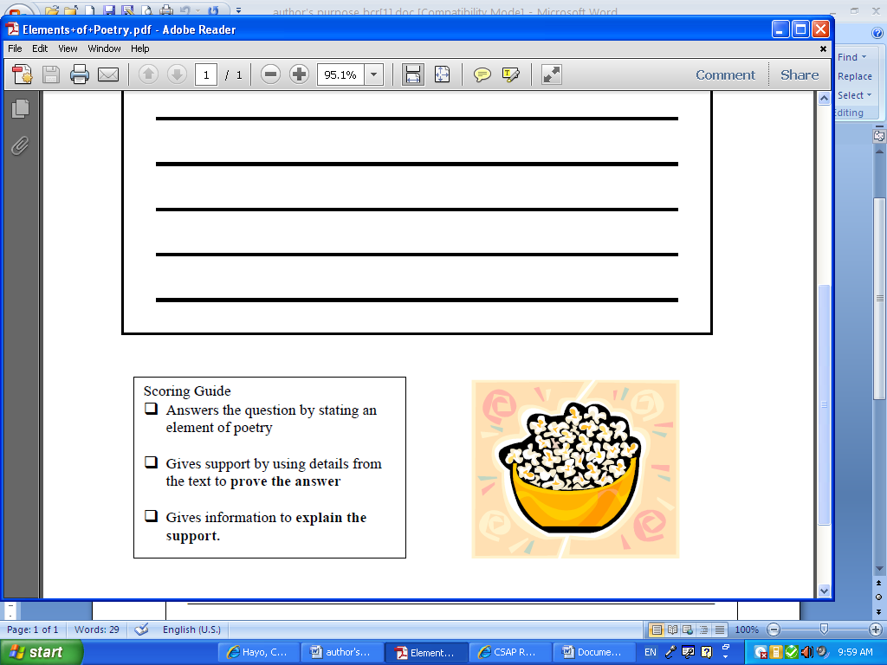

**Type your responses below each question or write your responses where your teacher instructs.**

What is the main idea of the poem?

In the second stanza, explain the meaning of the simile the author used. (Remember: Similes use like or as to compare.)

Which of these words best describes the poet’s attitude in the poem? Explain.

**annoyed, enthusiastic, protective, selfish**.