legendary
Define: | A story that has been handed down for years and has some basis in fact is legendary.
Example: | Stories about the Vikings are legendary because they are often part fact and part fiction.
Ask: | What legendary stories do you know?
muttered
Define: | Muttered means you spoke in a low, unclear tone with your mouth closed.
Example: | His mouth as shut, so I didn’t hear what he muttered.
Ask: | How is muttered different from whispered?
gaped
Define: | Gaped means you stared with your mouth open wide in surprise or wonder.
Example: | Sandra gaped as the large shark swam past her.
Ask: | What surprising things have you gaped at?
snickering
Define: | People are snickering if they are laughing in a disrespectful way.
Example: | After Kim slipped on ice, she heard people snickering.
Ask: | How is snickering different from laughing?
insult
Define: | An insult is a remark or action that hurts someone’s feelings or pride.
Example: | When the boys selected Steve last for the team, it was an insult.
Ask: | How is an insult different from on honor?
flinched
Define: | 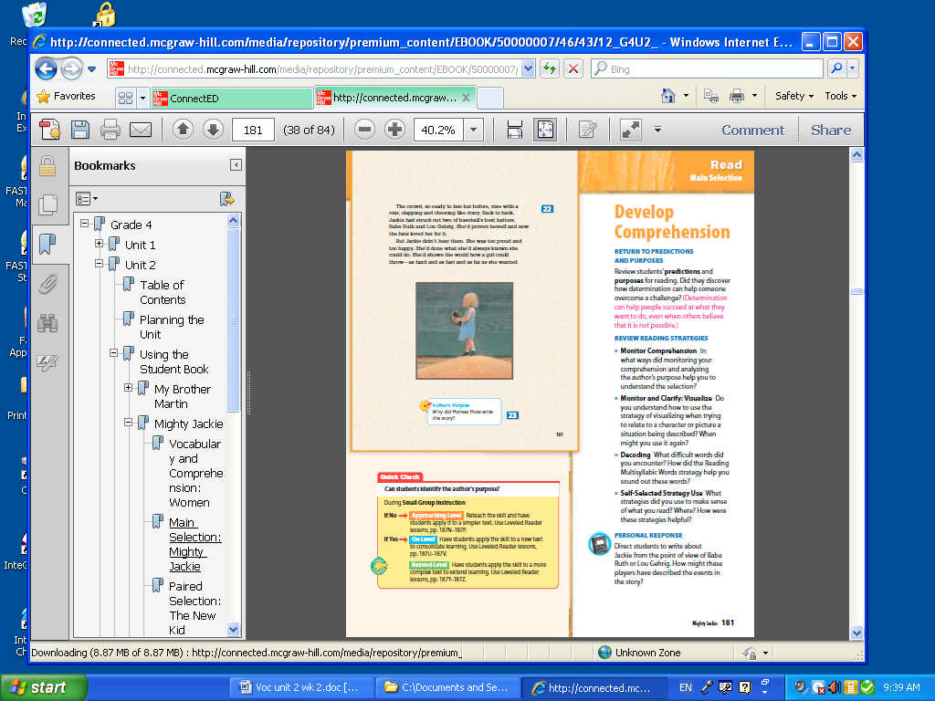  If you flinched, you reacted to something unpleasant by drawing back quickly.
Example: | Jerrod flinched when he saw his mother enter the principal’s office.
Ask: | What is a synonym for flinched?

