Name:______________________ Date:____________________ © D. Thomassen 2006

"The cricket in times square"
by George Selden
Pages 692-711 in Treasures

Genre: Fantasy (a story with invented characters, settings, or other elements that could not exist in real life).

Directions: After reading this text, complete the following organizer parts. Remember to reread any part of the story that confused you. You are a great reader.

Part I: Vocabulary Preinstruction:

Vocabulary Word: | How it is used in this story:
eavesdropping | Next to scrounging, eavesdropping on human beings was what he enjoyed most.
scuffling | From the shelf above came scuffling, like little feet feeling their way to the edge.
wistfully | “Yes,” said Chester. “I guess I’ll never see it again,” he added wistfully.
jumble | Inside the drain pipe, Tucker’s nest was a jumble of papers, scraps of cloth, buttons, lost jewelry, small change, and everything else that can be picked up in a subway station.
logical | “Very logical,” said Tucker Mouse, munching with his cheeks full.
acquaintance | “I’m very pleased to make your acquaintance,” said Harry Cat in a silky voice.
scornfully | “Germs!” said Tucker scornfully.

1. visual (“Follow along with your eyes as I spell it out loud”)
2. auditory (Hear the parts /p/ /ea/ /ch/)
3. kinesthetic (trace with eyes, write it on the table, hand, etc.)
4. phonics (break the word apart)—discuss prefixes, suffixes, roots, compounds, phonograms, double vowels, silent e.
5. meaning (give the definition and/or an example)
6. give an example. “I will be working with this group, meanwhile, this group will be at computers.”

-------------------------------------------------------------------------------------------------------------------



Part II: Comprehension

1. As you read this fantasy, fill in any information you learn about the setting, main characters, plot, problem, and, finally, the climax (solution):

What is the setting of this story (time and place)?  _____________________________  _____________________________  _____________________________  _____________________________  _____________________________  _____________________________  _____________________________  _____________________________  _____________________________ | Who are the main characters? Write down something important about each character.  _____________________________  _____________________________  _____________________________  _____________________________  _____________________________  _____________________________  _____________________________  _____________________________  _____________________________ |  | What is the plot (what is happening in this story)?  _____________________________  _____________________________  _____________________________  _____________________________  _____________________________  _____________________________  _____________________________  _____________________________  _____________________________
What is the problem in this story?  ____________________________________________  ____________________________________________  ____________________________________________  ____________________________________________  ____________________________________________  ____________________________________________  ____________________________________________  ____________________________________________  ____________________________________________ |  | What was the solution to the problem (usually the solution is the climax)?  ____________________________________________  ____________________________________________  ____________________________________________  ____________________________________________  ____________________________________________  ____________________________________________  ____________________________________________  ____________________________________________  ____________________________________________
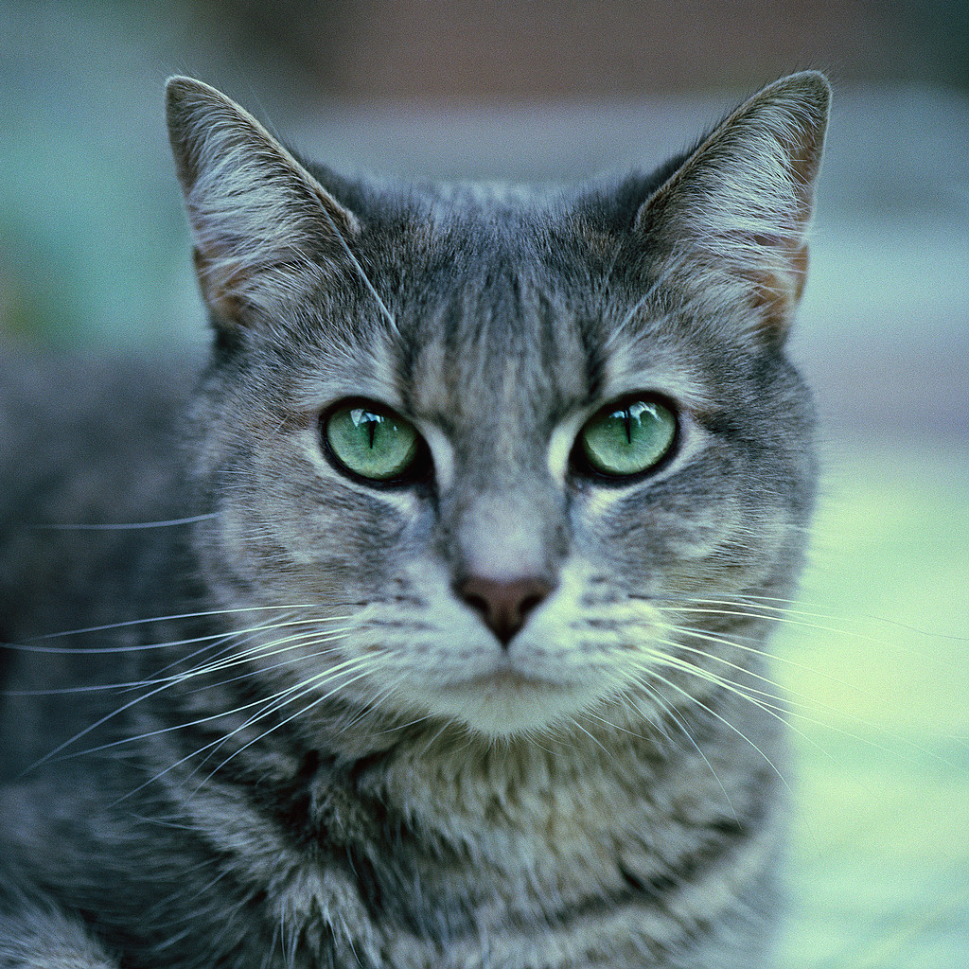

2. Read the following statements about liverwurst:

Liverwurst is a disgusting food to eat. ____fact _____opinion

Liverwurst is a sausage made from ground liver. _____fact _____opinion

Check whether the statement is a fact or an opinion. Explain how you knew whether the statement was a fact or an opinion.

__________________________________________________________________________________________

__________________________________________________________________________________________

__________________________________________________________________________________________

3. In the text Tucker Mouse says, “Imagine!” Tucker exclaimed. “Trapped under roast beef sandwiches! Well, there are worse fates.” What do you think Tucker meant by this statement?

__________________________________________________________________________________________

__________________________________________________________________________________________

__________________________________________________________________________________________

4. In the text Chester says, “And here I am,” Chester concluded forlornly. “I’ve been lying over there for three days not knowing what to do. At last I got so nervous I began to chirp.” Use the context (surrounding words) to determine the best synonym for the word forlornly.

unhappily

excitedly

tiredly

energetically

5. In the text Tucker Mouse says, “Harry is my oldest friend. He lives with me over in the drain pipe.” How do you think a mouse and a cat can help each other in a big city?

__________________________________________________________________________________________

__________________________________________________________________________________________

__________________________________________________________________________________________

6. How does Chester make the chirping sound? You must use a quote to support your answer.

__________________________________________________________________________________________

__________________________________________________________________________________________
7. What word best describes how Chester felt before he met Tucker and Harry?

excited

dreary

elated

surprised

8. Why did Chester feel better about being in the city when he saw a star shining above?

__________________________________________________________________________________________

__________________________________________________________________________________________

__________________________________________________________________________________________

9. What was the author’s purpose in writing this story?

The author wanted to persuade the reader to visit large cities like New York.

The author wanted to entertain the reader with a story about how a cricket ended up in New York and became friends with a cat and mouse.

The author wanted to inform the reader about the history of Times Square in New York.

The author wanted to persuade the reader to learn more about crickets, cats, and mice.

10. Sequence: Put the following events from the story in the proper ordering by placing a 1 in front of the event that occurred first, a 2 in front of the event that occurred second and so on:

_____Chester began to feel happy because of his two new friends.

_____Chester saw Times Square for the first time.

_____Chester makes a beautiful sound with his wings.

_____Chester describes how he got to New York.

_____Tucker meets Chester.

_____Harry sprung upon and landed right next to Tucker.

_____Chester looked up and saw a shining star.

_____Chester told Harry and Tucker he didn’t feel like he would make it in the city.
--------------------------------------------------------------------------------------------------------------------------------------

Part III: Compare and Contrast: Complete the following grid by comparing and contrasting mice, cats, and crickets.

Creatures we will be discussing: | Sketch what this creature looks like? | Describe how this creature is able to move from one place to another?  What verb would you use to describe its motion? | Would you like to have this creature for a pet? Explain why you would or would not want to have one as a pet. If you would like to have one as a pet, what would you name it? | Use a library reference and list one special fact you learned about this creature:
mouse

cat

cricket

Part IV: Fluency Practice: Follow the four-step fluency practice steps:

1. Read the following excerpt from the text to your teacher. You must focus on pronouncing each word correctly. Take your time and do a great job. Your teacher will then discuss any words that may have been difficult for you. Record your time in the space provided.
2. Read the following excerpt from the text to yourself. Record your second time in the space provided. Ask yourself: Do I understand what happened in the text?
3. Read the following excerpt from the text to a classmate. Record your third time in the space provided. Ask yourself: Is my fluency speed improving?
4. Read the following excerpt from the text to a parent or sibling. Have them sign in the space provided. This will let your teacher know that you completed the fourth step of your fluency practice.
Fluency Goal: Your fluency goal for this excerpt is to cut your time in half from your first reading to your fourth reading. If you do not complete your goal, you need to continue reading this excerpt until you accomplish that goal. When you have reached your goal, write down the main idea (one sentence) of your excerpt on the line provided. You will read this excerpt to your teacher one final time.

They were standing at one corner of the Times building, which is at the south end of Times Square. Above the cricket, towers that seemed like mountains of light rose up into the night sky. Even this late the neon signs were still blazing. Reds, blues, greens, and yellows flashed down on him. And the air was full of the roar of traffic and the hum of human beings. It was if Times Square were a kind of shell, with colors and noises breaking in great waves inside it. Chester’s heart hurt him and he closed his eyes. The sight was too terrible and beautiful for a cricket who up to now had measured high things by the height of his willow tree and sounds by the burble of a running brook.
“How do you like it? asked Tucker Mouse.
“Well—it’s—it’s quite something,” Chester stuttered.
“You should see it New Year’s Eve,” said Harry Cat.

157 words

First Read:__________ Second Read:__________ Third Read:__________ Fourth Read:__________

Parent Signature:_______________________

Main Idea:_________________________________________________________________________________

__________________________________________________________________________________________

__________________________________________________________________________________________


Summary Sheet Fiction ©1999 by Sopris West

Directions: Summarize the text you just read using the following procedure. Steps 1-3 will help you with your topic sentence. Steps 4-5 will help you get started on your summary paragraph.
1. Identify what you will be summarizing. Be specific—use names and titles.
The story Princess Harimau and the Tiger

2. Use one of these words (verbs) to help you organize your summary:
tells, lists, describes, explains, compares, gives, shows

3. Finish your thought:
The story Princess Harimau and the Tiger tells the story of a Princess and her friendship with her pet tiger named Shiva.

4. Create a beginning-middle-end outline: Make a list of the important events you would like to include in your summary.
(Use transition words: first, next, then, after that, finally…..)
Beginning (characters, setting)

Middle (problem, events)

End (solution to the problem)

5. Use your Beginning-Middle-End outline to write the summary paragraph:

____________________________________________________________________________________________________________

____________________________________________________________________________________________________________

____________________________________________________________________________________________________________

____________________________________________________________________________________________________________

____________________________________________________________________________________________________________

____________________________________________________________________________________________________________

____________________________________________________________________________________________________________

____________________________________________________________________________________________________________

____________________________________________________________________________________________________________

____________________________________________________________________________________________________________

____________________________________________________________________________________________________________

____________________________________________________________________________________________________________

____________________________________________________________________________________________________________

____________________________________________________________________________________________________________

____________________________________________________________________________________________________________

____________________________________________________________________________________________________________
Be sure to check your paragraph? Does it make sense? Does it look right? Does it sound right?

