Name:______________________ Date:____________________ © D. Thomassen 2006

"A walk in the desert"
by Rebecca L. Johnson
Pages 48-63 in Treasures

Genre: Informational Nonfiction (a detailed composition that sets out to explain something by presenting facts about it).
Directions: After reading this text, complete the following organizer parts. Remember to reread any part of the story that confused you. You are a great reader.

Part I: Vocabulary Preinstruction:

Vocabulary Word: | How it is used in this story:
climate | A biome’s climate, soil, plants, and animals are all connected this way.
silken | They spin silken webs among cactus spines.
lumbering | In one small patch of desert, you could see tiny skinks, chunky chuckwallas, spiny horned lizards, and lumbering Gila monsters.
swallows | The roadrunner catches the lizard by its tail and swallows it in one gulp.
lurk | Scorpions often lurk in crevices or under rocks during the day.
shimmer | Heat waves shimmer above the landscape.
eerie | They join voices in an eerie, wailing song.

1. visual (“Follow along with your eyes as I spell it out loud”)
2. auditory (Hear the parts /p/ /ea/ /ch/)
3. kinesthetic (trace with eyes, write it on the table, hand, etc.)
4. phonics (break the word apart)—discuss prefixes, suffixes, roots, compounds, phonograms, double vowels, silent e.
5. meaning (give the definition and/or an example)
6. give an example. “I will be working with this group, meanwhile, this group will be at computers.”

-------------------------------------------------------------------------------------------------------------------

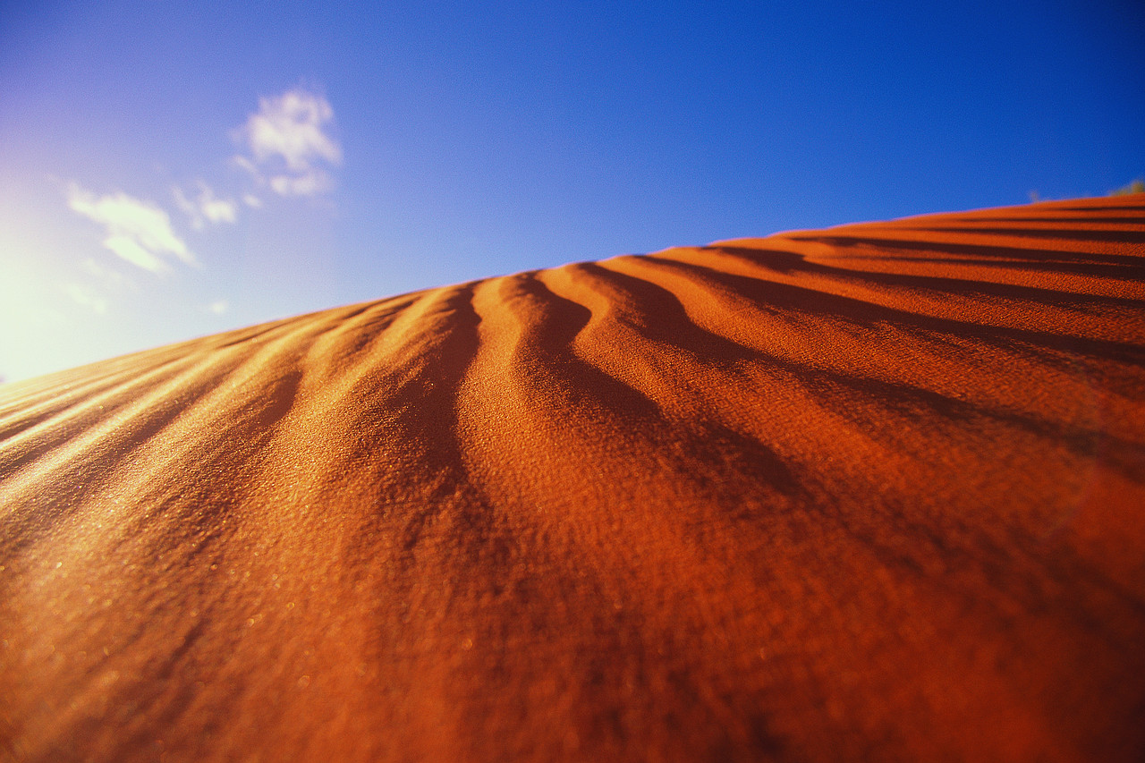

Part II: Comprehension

1. Using the map on page 50, describe how you can tell where the different biomes are located?

_____________________________________________________________________________

_____________________________________________________________________________

2. In the text it days, “In that community, every living thing depends on other community members for survival.” Describe some ways that living things depend on each other for survival:

_____________________________________________________________________________

_____________________________________________________________________________

3. In the text it says, “Many desert animals are nocturnal.” This statement is an example of…

an opinion.

a fact.

a question.

a theory.

4. List two advantages (+) and disadvantages (-) for animals that are nocturnal (active only at night):

Advantages (+) | Disadvantages (-)
1. | 1.
2. | 2.

5. Using a quote from the text, describe how the shape of a roadrunner’s feet help with running.

_____________________________________________________________________________
6. In the text it says, “By noon, even the coyotes are panting. It’s well over 100 degrees.” Why is it important for these animals to seek shelter and rest during this part of the day?

_____________________________________________________________________________

_____________________________________________________________________________

7. In the text it says, “A rattlesnake’s rattle is made up of a row of large, dry scales.” This statement is an example of…

an opinion.

a fact.

a question.

a theory.

8. In the text it says, “Curled leaves lose less water to the hot, dry air.” Explain why you think curled leaves lose less water when compared to flatter leaves?”

_____________________________________________________________________________

_____________________________________________________________________________

9. Choose your favorite animal discussed in the text. List your animal and complete the following information grid:
Favorite Animal:____________________

Where does it live? | What does it eat? | What does it look like? | Who are his enemies? | List an interesting fact:

10. What was the author’s purpose in writing this selection?

The author’s purpose was to persuade the reader to move to the desert.

The author’s purpose was to inform the reader about the climate, soil, plants, and animals in the desert.

The author’s purpose was to entertain the reader with funny desert animal stories.

The author’s purpose was to persuade the reader to create a map of different biomes.
Part III: Compare and Contrast

Analogies: We use analogies to identify relationships between pairs of concepts (Marzano 2001).

Examples: happy:sad::big:small ("happy is to sad as big is to small")

Directions: Complete these analogies that were created from the text you just read.

biome:desert::_______________:earth

nonfiction:______________::fiction:untrue

reptile:lizard::_______________:ants

swallow:mouth::run:_______________

enormous:_______________::quiet:loud

_______________:wet::desert:dry

Part IV: Fluency Practice: Follow the four-step fluency practice steps:

1. Read the following excerpt from the text to your teacher. You must focus on pronouncing each word correctly. Take your time and do a great job. Your teacher will then discuss any words that may have been difficult for you. Record your time in the space provided.
2. Read the following excerpt from the text to yourself. Record your second time in the space provided. Ask yourself: Do I understand what happened in the text?
3. Read the following excerpt from the text to a classmate. Record your third time in the space provided. Ask yourself: Is my fluency speed improving?
4. Read the following excerpt from the text to a parent or sibling. Have them sign in the space provided. This will let your teacher know that you completed the fourth step of your fluency practice.

Fluency Goal: Your fluency goal for this excerpt is to cut your time in half from your first reading to your fourth reading. If you do not complete your goal, you need to continue reading this excerpt until you accomplish that goal. When you have reached your goal, write down the main idea (one sentence) of your excerpt on the line provided. You will read this excerpt to your teacher one final time.

Deserts are surrounded by other kinds of landscapes. Scientists call these different land zones biomes. All the plants and animals in a biome form a community. In that community, every living thing depends on other community members for survival. A biome’s climate, soil, plants, and animals are all connected this way.
Deserts have a very dry climate. They do get a little rain, but it doesn’t come regularly. One storm might drench a desert with several inches of rain in just a few hours. It might not rain again for months—even years.
Desert plants provide many animals with food and water. Here comes a desert tortoise. It shuffles slowly along and stops often to rest. The tortoise stretches its long neck to nibble a wildflower. Tortoises rarely drink. They get nearly all the water they need from the plants they eat.

142 words
First Read:__________ Second Read:__________ Third Read:__________ Fourth Read:__________

Parent Signature:_______________________

Main Idea:_________________________________________________________________________________

__________________________________________________________________________________________

Summary Sheet Non-Fiction ©1999 by Sopris West

Directions: Summarize the text you just read using the following procedure. Steps 1-3 will help you with your topic sentence. Steps 4-5 will help you get started on your summary paragraph.
1. Identify what you will be summarizing. Be specific—use names and titles.
The article "Dan Jansen: In Quest of Gold"

2. Use one of these words (verbs) to help you organize your summary:
tells, lists, describes, explains, compares, gives, shows

3. Finish your thought:
The article "Dan Jansen: In Quest of Gold" describes how an Olympic speed skater named Dan Jansen tried many times to get a gold medal in the Olympics.

4. Create a fact outline: Make a list of the facts you would like to include in your summary.

Fact #1:_____________________________________________________________________________

Fact #2:_____________________________________________________________________________

Fact #3:_____________________________________________________________________________

Fact #4:_____________________________________________________________________________

5. Use your fact outline to write the summary paragraph:

____________________________________________________________________________________________________________

____________________________________________________________________________________________________________

____________________________________________________________________________________________________________

____________________________________________________________________________________________________________

____________________________________________________________________________________________________________

____________________________________________________________________________________________________________

____________________________________________________________________________________________________________

____________________________________________________________________________________________________________

____________________________________________________________________________________________________________

____________________________________________________________________________________________________________

____________________________________________________________________________________________________________

____________________________________________________________________________________________________________

____________________________________________________________________________________________________________

____________________________________________________________________________________________________________

____________________________________________________________________________________________________________

____________________________________________________________________________________________________________

____________________________________________________________________________________________________________

____________________________________________________________________________________________________________

____________________________________________________________________________________________________________

____________________________________________________________________________________________________________

____________________________________________________________________________________________________________

____________________________________________________________________________________________________________

____________________________________________________________________________________________________________

____________________________________________________________________________________________________________

Be sure to check your paragraph? Does it make sense? Does it look right? Does it sound right?
