Name:______________________ Date:____________________ © D. Thomassen 2006

"roadrunner’s dance"
by Johanna Hurwitz
Pages 280-297 in Treasures

Genre: Folktale (a story based on the traditions of a people or region, told by parents to children and then by the children to their children).

Directions: After reading this text, complete the following organizer parts. Remember to reread any part of the story that confused you. You are a great reader.

Part I: Vocabulary Preinstruction:

Vocabulary Word: | How it is used in this story:
interfere | She did not like to interfere in the lives of the people and animals, but she knew that something must be done.
guardian | “If you help me, together we can make a guardian of the road,” Desert Woman said.
agile | He will be agile and fast.
tottered | He tottered forward, then backward, then forward, and fell flat on his face.
awkward | He was too awkward.
proclaimed | “Now we can visit our neighbors in peace and go to our cornfields without fear!” the elders proclaimed.

1. visual (“Follow along with your eyes as I spell it out loud”)
2. auditory (Hear the parts /p/ /ea/ /ch/)
3. kinesthetic (trace with eyes, write it on the table, hand, etc.)
4. phonics (break the word apart)—discuss prefixes, suffixes, roots, compounds, phonograms, double vowels, silent e.
5. meaning (give the definition and/or an example)
6. give an example. “I will be working with this group, meanwhile, this group will be at computers.”

-------------------------------------------------------------------------------------------------------------------
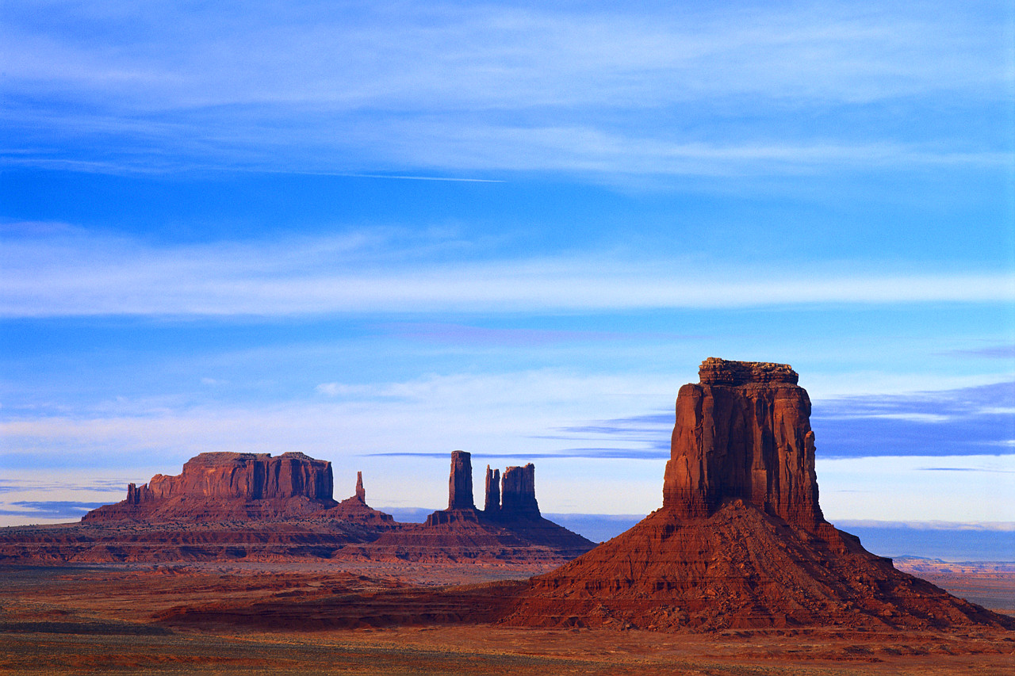

Part II: Comprehension

1. Describe the problem that the family faced in the beginning of this story?

__________________________________________________________________________________________

__________________________________________________________________________________________

__________________________________________________________________________________________

2. What would you do to solve this problem?

__________________________________________________________________________________________

__________________________________________________________________________________________

__________________________________________________________________________________________

3. The Desert Woman most likely put a rattle on the snake so that…

he would learn to play music.

he would have something to chew on when there was no food.

he would not be able to move as quickly.

he would be heard by anyone wanting to go on the road.

4. Why did the animals quickly agree to Desert Woman’s decision to make a new animal?

__________________________________________________________________________________________

__________________________________________________________________________________________

__________________________________________________________________________________________

5. What word best describes how the Roadrunner felt when he first began to dance, run, and jump?

confident

frustrated

excited

tired

6. Explain how you knew which word to choose in question #5.

__________________________________________________________________________________________

__________________________________________________________________________________________

7. Read the following statement about rattlesnakes:

Rattlesnakes are the scariest snakes in the world.

Is the previous statement a fact or an opinion? Explain your answer.

__________________________________________________________________________________________

__________________________________________________________________________________________

8. Explain how the Roadrunner was able to defeat the rattlesnake? What was the result of the rattlesnake’s defeat?

Explanation:______________________________________________________________________________

__________________________________________________________________________________________

Result:___________________________________________________________________________________

_________________________________________________________________________________________

9. What was the author’s purpose in writing this story?

The author wanted to persuade the reader to stay away from roads that have rattlesnakes.

The author wanted to entertain the reader with a story about how a roadrunner was created.

The author wanted to inform the reader about how a roadrunner was made.

The author wanted to inform the reader about the desert ecosystem.

10. Sequence: Put the following events from the story in the proper ordering by placing a 1 in front of the event that occurred first, a 2 in front of the event that occurred second and so on:
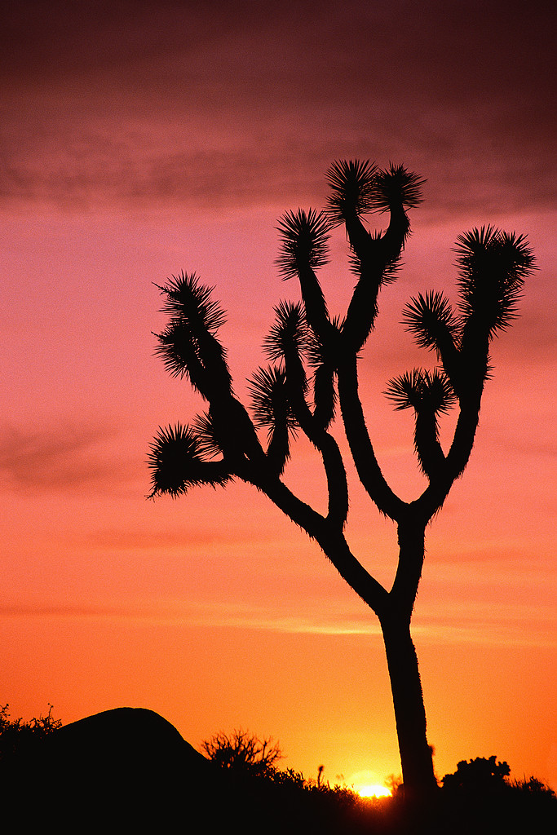
_____The animals and the Desert Woman created a new animal.

_____The elders went to the Desert Woman for help.

_____The Desert Woman gave the snake a rattle.

_____The Roadrunner practiced and became a very graceful dancer.

_____The Rattlesnake promised to not bother people on the road anymore.

_____The Roadrunner practiced dancing and jumping but continually fell down.

_____The Roadrunner ran into the Rattlesnake while racing down the road.

_____A snake threatens a family that is heading to the cornfield.
--------------------------------------------------------------------------------------------------------------------------------------
Part III: Compare and Contrast: Complete the following grid by comparing and contrasting the different body parts used by Desert Woman and the desert animals to make the roadrunner:

Roadrunner Body  Parts: | What is the  function of this  body part? | Why do you think this body part is or is not important? | What would you use this body part for if you suddenly received it from the Desert Woman? | Rank the following body parts in order of their importance (1=most important and 5 being least important):
slender legs

long tail

feathers

long beak

sharp eyes

Part IV: Fluency Practice: Follow the four-step fluency practice steps:

1. Read the following excerpt from the text to your teacher. You must focus on pronouncing each word correctly. Take your time and do a great job. Your teacher will then discuss any words that may have been difficult for you. Record your time in the space provided.
2. Read the following excerpt from the text to yourself. Record your second time in the space provided. Ask yourself: Do I understand what happened in the text?
3. Read the following excerpt from the text to a classmate. Record your third time in the space provided. Ask yourself: Is my fluency speed improving?
4. Read the following excerpt from the text to a parent or sibling. Have them sign in the space provided. This will let your teacher know that you completed the fourth step of your fluency practice.

Fluency Goal: Your fluency goal for this excerpt is to cut your time in half from your first reading to your fourth reading. If you do not complete your goal, you need to continue reading this excerpt until you accomplish that goal. When you have reached your goal, write down the main idea (one sentence) of your excerpt on the line provided. You will read this excerpt to your teacher one final time.

He struck at Roadrunner, but Roadrunner hopped out of the way.
“Stand still!” Rattlesnake cried and lunged again.
But Roadrunner danced gracefully out of reach.
Rattlesnake coiled for one more attempt. He struck like lightning, but fell flat on his face. Roadrunner had jumped to safety.
Now it was Roadrunner’s turn. He ruffled his feathers and danced in circles around Rattlesnake. Again and again he pecked at the bully’s tail. Like a whirlwind, he spun around Rattlesnake until the serpent grew dizzy. His eyes grew crossed and his tongue hung limply out of his mouth.
“You win! You win!” Rattlesnake cried.
“You are not king of the road, and you must not frighten those who use it,” Roadrunner said sternly.
“I promise, I promise,” the beaten Rattlesnake said and quietly slunk down his hole.

134 words

First Read:__________ Second Read:__________ Third Read:__________ Fourth Read:__________

Parent Signature:_______________________

Main Idea:_________________________________________________________________________________

__________________________________________________________________________________________

Summary Sheet Fiction ©1999 by Sopris West

Directions: Summarize the text you just read using the following procedure. Steps 1-3 will help you with your topic sentence. Steps 4-5 will help you get started on your summary paragraph.
1. Identify what you will be summarizing. Be specific—use names and titles.
The story Princess Harimau and the Tiger

2. Use one of these words (verbs) to help you organize your summary:
tells, lists, describes, explains, compares, gives, shows

3. Finish your thought:
The story Princess Harimau and the Tiger tells the story of a Princess and her friendship with her pet tiger named Shiva.

4. Create a beginning-middle-end outline: Make a list of the important events you would like to include in your summary.
(Use transition words: first, next, then, after that, finally…..)
Beginning (characters, setting)

Middle (problem, events)

End (solution to the problem)

5. Use your Beginning-Middle-End outline to write the summary paragraph:

____________________________________________________________________________________________________________

____________________________________________________________________________________________________________

____________________________________________________________________________________________________________

____________________________________________________________________________________________________________

____________________________________________________________________________________________________________

____________________________________________________________________________________________________________

____________________________________________________________________________________________________________

____________________________________________________________________________________________________________

____________________________________________________________________________________________________________

____________________________________________________________________________________________________________

____________________________________________________________________________________________________________

____________________________________________________________________________________________________________

____________________________________________________________________________________________________________

____________________________________________________________________________________________________________

____________________________________________________________________________________________________________

____________________________________________________________________________________________________________
Be sure to check your paragraph? Does it make sense? Does it look right? Does it sound right?

