Name:______________________ Date:____________________ © D. Thomassen 2006
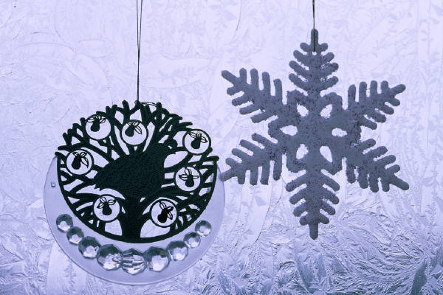
"snowflake bentley"
by Jacqueline Briggs Martin
Pages 378-401 in Treasures

Genre: Biography (is a story about the life of a real person written by someone else).

Directions: After reading this text, complete the following organizer parts. Remember to reread any part of the story that confused you. You are a great reader.

Part I: Vocabulary Preinstruction:

Vocabulary Word: | How it is used in this story:
microscope | When his mother gave him an old microscope, he used it to look at flowers, raindrops, and blades of grass.
negatives | The camera made images on large glass negatives.
magnify | It’s microscope could magnify a tiny crystal from sixty-four to 3,600 times its actual size.
foolishness | “Fussing with snow is just foolishness,” his father said.
evaporate | He had to work fast or the snowflake would evaporate before he could slide it into place and take its picture.
inspire | Artists and designers used the photographs to inspire their own work.
blizzard | Less than a month after turning the first page of his book, Willie walked six miles home in a blizzard to make more pictures.
technique | For fifty years Wilson A. Bentley, a simple farmer, developed his technique of microphotography to reveal to the world the grandeur and mystery of the snowflake.

1. visual (“Follow along with your eyes as I spell it out loud”)
2. auditory (Hear the parts /p/ /ea/ /ch/)
3. kinesthetic (trace with eyes, write it on the table, hand, etc.)
4. phonics (break the word apart)—discuss prefixes, suffixes, roots, compounds, phonograms, double vowels, silent e.
5. meaning (give the definition and/or an example)
6. give an example. “I will be working with this group, meanwhile, this group will be at computers.”
-------------------------------------------------------------------------------------------------------------------
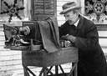

Part II: Comprehension

1. In the text it says, “Wilson Bentley was born February 9, 1865, on a farm in Jericho, Vermont, between Lake Champlain and Mount Mansfield, in the heart of the ‘snowbelt,’ where the annual snowfall is about 120 inches.” Approximately how much snow would fall in Jericho, Vermont in 4 years? Show your work in the box that is provided:

400 inches

360 inches

480 inches

520 inches

Describe how you were able to solve this problem.

__________________________________________________________________________________________

__________________________________________________________________________________________

2. Why was Charlie unable to collect and share snowflakes with his family?

__________________________________________________________________________________________

__________________________________________________________________________________________

3. In the text it says, “Their intricate patterns were even more beautiful than he had imagined.”

One dictionary contains the following two definitions for the word intricate:

1. | having many interrelated parts or facets; entangled or involved.

2. | complex; complicated; hard to understand, work, or make.

Which definition best describes a snowflake? Explain your decision:

__________________________________________________________________________________________

__________________________________________________________________________________________

__________________________________________________________________________________________

__________________________________________________________________________________________

4. Why did Charlie begin sketching snowflake designs?

__________________________________________________________________________________________

__________________________________________________________________________________________

5. What did Willie’s father think of his idea to photograph snowflakes?

Willie’s father thought it was a very smart way to study snowflakes.

Willie’s father thought it was quite silly to take pictures of snowflakes.

Willie’s father thought it would make their family quite wealthy.

Willie’s father thought the idea would certainly make Willie sick from being out in the cold.

6. Willie discovered that no two snowflake crystals were alike. What reason did Willie discover to explain why no two snowflakes are alike?

__________________________________________________________________________________________

__________________________________________________________________________________________

__________________________________________________________________________________________

__________________________________________________________________________________________

7. List two difficulties Willie faced when trying to take pictures of snowflakes:

a.________________________________________________________________________________________

b.________________________________________________________________________________________

8. In the text it says, “Many colleges and universities bought lantern slide copies of his photographs and added to their collections each year.” Why do you think the colleges and universities bought crystal pictures from Willie?

__________________________________________________________________________________________

__________________________________________________________________________________________

__________________________________________________________________________________________

__________________________________________________________________________________________

9. In the text it says, “The little farmer came to be known as the world’s expert on snow, ‘the Snowflake Man.’ But he never grew rich. He spent every penny on his pictures.” Willie spent a good portion of his life working and studying snow, but, as the text says, it never made him rich. How do you think Willie felt about not becoming rich from all his work? Explain your answer.

__________________________________________________________________________________________

__________________________________________________________________________________________

__________________________________________________________________________________________

__________________________________________________________________________________________
10. What was the author’s purpose in writing this selection?

The author’s purpose was to persuade the reader to try and take pictures of snowflakes.

The author’s purpose was to inform the reader about the massive amount of snow that falls in Jericho, Vermont annually.

The author’s purpose was to inform the reader about the contributions made by Willie Bentley in the area of snowflake crystal photography.

The author’s purpose was to entertain the reader with a funny story about a little boy who tried to capture snowflakes and prove that none of them were the same.

Part III: Compare and Contrast: Use the following compare and contrast grid to discover the differences and similarities between the tools used by Snowflake Bentley to study snowflakes.

Tools used by Snowflake Bentley to study snowflakes | How would this tool help Snowflake Bentley study snowflakes?  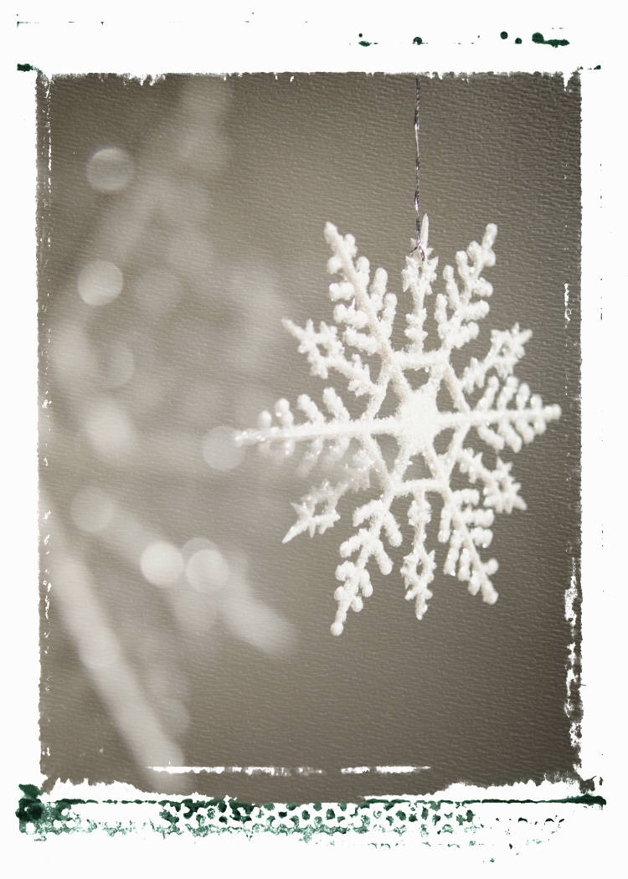 | Why is this specific tool an important one for scientists? | Rank the following tools in order of importance (1=most important and 4 being the least important):
Sketches
microscope

photographs

science journal

Part IV: Fluency Practice: Follow the four-step fluency practice steps:

1. Read the following excerpt from the text to your teacher. You must focus on pronouncing each word correctly. Take your time and do a great job. Your teacher will then discuss any words that may have been difficult for you. Record your time in the space provided.
2. Read the following excerpt from the text to yourself. Record your second time in the space provided. Ask yourself: Do I understand what happened in the text?
3. Read the following excerpt from the text to a classmate. Record your third time in the space provided. Ask yourself: Is my fluency speed improving?
4. Read the following excerpt from the text to a parent or sibling. Have them sign in the space provided. This will let your teacher know that you completed the fourth step of your fluency practice.

Fluency Goal: Your fluency goal for this excerpt is to cut your time in half from your first reading to your fourth reading. If you do not complete your goal, you need to continue reading this excerpt until you accomplish that goal. When you have reached your goal, write down the main idea (one sentence) of your excerpt on the line provided. You will read this excerpt to your teacher one final time.

Less than a month after turning the first page of his book, Willie walked home in a blizzard to make more pictures. He became ill with pneumonia after that walk and died two weeks later.
A monument was built for Willie in the center of town. The girls and boys who had been his neighbors grew up and told their sons and daughters the story of the man who loved snow. Forty years after Wilson Bentley’s death, children in his village worked to set up a museum in honor of the farmer-scientist.
And his book has taken the delicate snow crystals that once blew across Vermont, past mountains, over the earth. Neighbors and strangers have come to know of the icy wonders that land on their own mittens—thanks to Snowflake Bentley.

132 words

First Read:__________ Second Read:__________ Third Read:__________ Fourth Read:__________

Parent Signature:_______________________

Main Idea:_________________________________________________________________________________

__________________________________________________________________________________________

__________________________________________________________________________________________

Summary Sheet Non-Fiction ©1999 by Sopris West

Directions: Summarize the text you just read using the following procedure. Steps 1-3 will help you with your topic sentence. Steps 4-5 will help you get started on your summary paragraph.
1. Identify what you will be summarizing. Be specific—use names and titles.
The article "Dan Jansen: In Quest of Gold"

2. Use one of these words (verbs) to help you organize your summary:
tells, lists, describes, explains, compares, gives, shows

3. Finish your thought:
The article "Dan Jansen: In Quest of Gold" describes how an Olympic speed skater named Dan Jansen tried many times to get a gold medal in the Olympics.

4. Create a fact outline: Make a list of the facts you would like to include in your summary.

Fact #1:_____________________________________________________________________________

Fact #2:_____________________________________________________________________________

Fact #3:_____________________________________________________________________________

Fact #4:_____________________________________________________________________________

5. Use your fact outline to write the summary paragraph:

____________________________________________________________________________________________________________

____________________________________________________________________________________________________________

____________________________________________________________________________________________________________

____________________________________________________________________________________________________________

____________________________________________________________________________________________________________

____________________________________________________________________________________________________________

____________________________________________________________________________________________________________

____________________________________________________________________________________________________________

____________________________________________________________________________________________________________

____________________________________________________________________________________________________________

____________________________________________________________________________________________________________

____________________________________________________________________________________________________________

____________________________________________________________________________________________________________

____________________________________________________________________________________________________________

____________________________________________________________________________________________________________

____________________________________________________________________________________________________________

____________________________________________________________________________________________________________

Be sure to check your paragraph? Does it make sense? Does it look right? Does it sound right?

