Routine Artful Thinking | Steps/Procedure/Question | Use when you want students to: | Artwork  Example | Common Core Connections  Reading Gr. 4/Gr. 8 | Thinking Map
Looking/  Listening 10x2  KNOWLEDGE  Good starting point for deeper thinking- can be followed by other routines. | - Look at a piece of art/listen to piece of music for 30 seconds  - List 10 words or phrases about any aspect of what you see or hear.  - Share words  - Repeat | -Make careful observations about an object, image or work of art.  -Generate/brainstorm descriptive words or phrases for a pre-writing, discussion activity. | 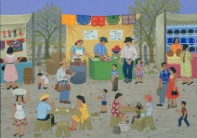  The Fair at Reynosa  Carmen Lomas Garza  1987 | Craft and Structure: 4  4. Determine the meaning of general academic and domain-specific words and phrases in a text relevant to a grade topic or subject area. Gr. 4  4.: Determine the meaning of words and phrases as they are used in a text, including figurative and connotative meanings. Gr. 8 | Circle Map  Bubble Map  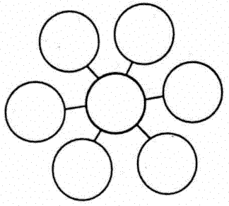
I See. I Think. I Wonder.  KNOWLEDGE  INTERPRETATION | - What do you see (hear)?  - What do you think about that?  - What does it make you wonder? | -Make careful observations and thoughtful interpretations.  -Make inferences. | 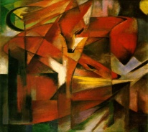  Foxes  Marc Franz  1939 | Key Ideas and Details: 1 & 2  1. Refer to details and examples in a text when explaining what the text says explicitly and when drawing inferences from the text. Gr. 4  1. Cite the textual evidence that most strongly supports an analysis of what the text says explicitly as well as inferences drawn from the text. Gr. 8  2. Determine the main idea of a text and explain how it is supported by key details; summarize the  text. Gr. 4  2. Determine a central idea of a text and analyze its development over the course of the text, including its relationship to supporting ideas; provide an objective summary of the text. Gr. 8 | Tree Map  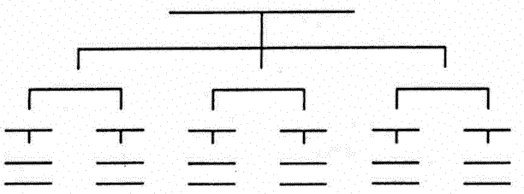
The Elaboration Game  KNOWLEDGE  Good starting point for writing: can be followed by other routines. | - One person identifies a specific section of the artwork and describes what he or she sees(hears).  - Another person elaborates on the first person’s observations by adding more detail about the section.  - A third person elaborates further by adding yet more detail, and  - a fourth person adds yet more. | -Describe.  -Elaborate.  -Distinguish between what they see and what they interpret.  -Practice narrative, expository writing skills. | 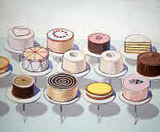  Cakes  Wayne Thibeaud  1963 | Key Ideas and Details: 2 (see above)  Craft and Structure: 4 (see above) | Bubble Map  Flow Map  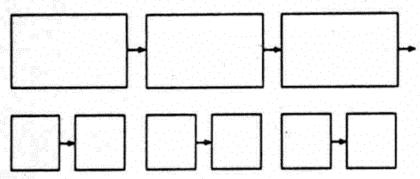
What Makes you Say That?  COMPREHENSION  Good starting point for deeper thinking- can be followed by other routines. | - What’s going on (happening) in the picture?  - What makes you say that? | -Describe what they see or know and provide evidence and explanation (evidence based reasoning).  -Provide text or graphic evidence for thinking and writing. | 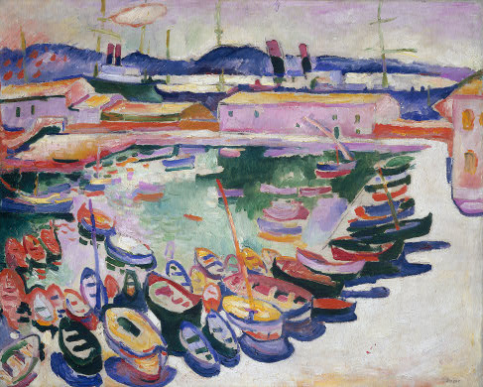  The Port of La Ciotat, Georges Braque  1907 | Key Ideas and Details: 1, 2 (see above) & 3  3. Explain events, procedures, ideas, or concepts in historical, scientific or technical text, including what happened and why, based on specific information in the text. Gr. 4  3. Analyze how a text makes connections among and distinctions between individuals, ideas, or events (e.g. through comparisons, analogies, or categories.) Gr. 8  Craft and Structure: 5  5. Describe the overall structure (e.g., chronology, comparison, cause/effect, problem/solution) of events, ideas, concepts or information in a text or part of a  text. Gr. 4  5. Analyze in detail the structure of a specific paragraph in a text, including the role of particular sentences in developing and refining a key concept. Gr. 8 | Tree Map
Colors, Shapes, Lines  KNOWLEDGE | - What colors do you see? Describe them.  - What kinds of shapes do you see? Describe them.  - What kinds of lines do you see? Describe them. | - Observe details.  - Generate/brainstorm descriptive words or phrases.  - prepare for formal analysis of Art. | 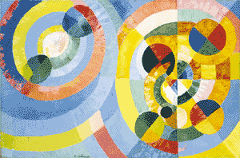  Circular Forms  Robert Delaunay  1930 | Craft and Structure: 4 (see above) | Tree Map
Beginning. Middle. End.  COMPREHENSION  APPLICATION | Choose one of the 3 questions:  - If this artwork is the beginning of a story, what might happen next?  - If it this artwork is the middle of a story, what might have happened before? What might be about to happen?  - If this artwork is the end of a story, what might the story be? | -Make observations and use their imagination to elaborate on and extend their ideas.  -Look for connections, patterns, and meanings.  -Develop writing or storytelling (narrative) skills and sequencing. | 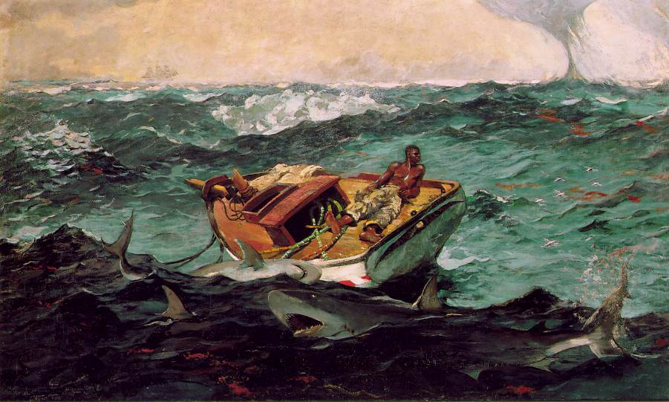  The Gulf Stream,  Winslow Homer  1899 | Key Ideas and Details: 1 & 2 (see above)  Craft and Structure: 5 (see above)  Writing:  3. Write narratives in which they recount a well-elaborated event or short sequence of events, include details to describe actions, thoughts, and feelings, use temporal words to signal event order, and provide a sense of closure. Gr. 4  3. Write narratives to develop real or imagined experiences to or events using effective technique, relevant descriptive details, and well structured event sequences. Gr. 8 | Flow Map  Multi-Flow Map
Claim. Support. Question.  COMPREHENSION  ANALYSIS  SYNTHESIS | - Make a claim about the artwork or topic (An explanation or interpretation of some aspect of the art-work or topic).  - Identify/provide support for your claim (things you see, feel, and know that support your claim.)  - Ask a question related to your claim (What’s left hanging? What isn’t explained? What new reasons does your claim raise?) | -Reason and provide evidence or support, especially with topics in the curriculum are open to interpretation.  -Practice argument writing skills. | 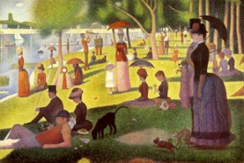  A Sunday on the Grande Jatte  Georges-Pierre Seurat  1884 | Key Ideas and Details: 1 & 3 (see above)  Integration of Knowledge: 8 (see above)  8. Explain how an author uses reasons and evidence to support particular points in a text. Gr. 4  8. Delineate and evaluate the argument and specific claims in a text, assessing whether the reasoning is sound and the evidence is relevant and sufficient; recognize when irrelevant evidence is introduced.  Gr. 8 | Tree Map  *When using this routine for answering assessment questions, choose Thinking Map that is appropriate for the question and apply the frame of reference to help students develop their question or extension.
Creative Questions  ANALYSIS  SYNTHESIS | Brainstorm a list of at least 12 questions about the artwork or topic. Using starters:  Why?  What are the reasons?  What if?  What is the purpose of?  How would it be different if?  Suppose that  What if we knew?  What would change if? | -Make inferences.  -Develop good questions.  -Think deeply about a topic. | 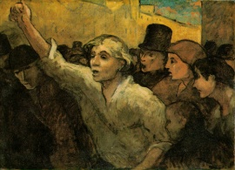  The Uprising  Honore Daumier  1860 | Key Ideas and Details: 1 & 3 (see above) | Frame of Reference  (Thinking Map depends on the question the students generate)
Creative Comparisons  ANALYSIS | - What do you see in the artwork? What do you know about the topic?  - Choose a category (musical instruments, plants, video game, toy city, part of the body, etc. )  - Imagine: If this topic/artwork was a kind of (provide category), what would it be?  - Explain three ways that it compares. | -Use metaphorical thinking to create comparisons between dissimilar things.  -Understand unfamiliar subjects by linking it to what they already know. | 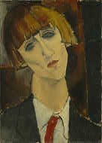  Madame Kisling  Amedeo Modigliani  1917 | Craft and Structure: 4 & 5 (see above)  Key Ideas and Details: 3 (see above)  Integration of Knowledge: 9  9. Integrate knowledge from several texts on the same topic in order to write or speak about the subject knowledgeably. Gr. 4  9. Analyze a case in which two or more texts provide conflicting information on the same topic and identify where the texts disagree on matters of fact or interpretation. Gr. 8 | Double-Bubble Map  Bridge Map  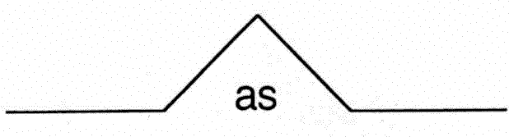
Connect. Extend. Challenge.  APPLICATION  ANALYSIS  SYNTHESIS | Connect: How is the artwork, the ideas, or information presented CONNECTED to what you already knew?  Extend: What new ideas did you get that EXTENDED or pushed your thinking in new directions?  Challenge: What is still CHALLENGING or confusing for you to get your mind around? What questions, wonderings or puzzles do you now have? | -Make connections between new ideas and prior knowledge.  -Reflect on/assess their learning and increase metacognition.  -Review/summarize new material, lesson or unit. | 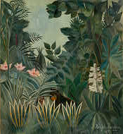  The Equatorial Jungle  Henri Rouseau  1909 | Key Ideas and Details: 1 & 3(see above)  Integration of Knowledge: 8 (see above) | Multi-Flow Map  Frame of Reference
Perceive. Know. Care About.  ANALYSIS  EVALUATION | - What can the person or thing perceive?  - What might the person or thing know about or believe?  - What might the person or thing care about? | -Explore diverse perspectives and viewpoints.  -Make inferences.  -Connect to abstract concepts, pictures, or events. | 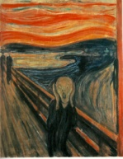  The Scream  Edvard Munch,  1893 | Craft and Structure: 6  6. Analyze multiple accounts of the same event or topic, noting important similarities and differences in the point of view they represent. Gr. 4  6. Determine the author’s point of view or purpose in a text and analyze how the author acknowledges and responds to conflicting evidence or viewpoints. Gr. 8 | Bubble Map  (use the Frame of Reference to identify the point of view)
Think. Puzzle. Explore.  APPLICATION  ANALYSIS | - What do you think about this artwork or topic?  - What questions or puzzles do you have?  - What does the topic or artwork make you want to explore? | -Connect to prior knowledge.  -Develop own questions of investigation. | 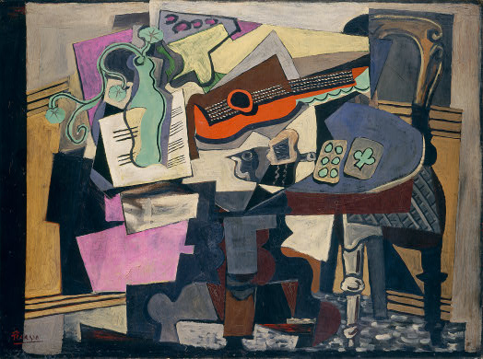  Still Life  Pablo Picasso  1918 | Key Ideas and Details: 2 & 3 (see above)  Craft and Structure: 5 (see above)  Integration of Knowledge: 8 & 9 (see above) | Circle Map  Frame of Reference  (Thinking Map depends on the question the students generate)
Headlines  COMPREHENSION  ANALYSIS  EVALUATION | - If you were to write a headline for this topic or issue right now that captured the most important aspect that should be remembered, what would that headline be?  - (Later) How has your headline changed based on today’s discussion? How does it differ from what you would have said yesterday? | -Summarize lesson, unit.  -Draw conclusions. | 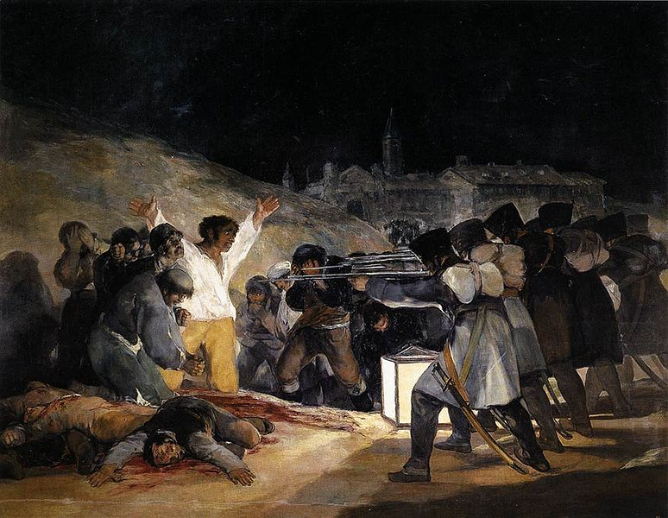  The Third of May 1801  Francisco Goya  1814 | Key Ideas and Details: 2 (see above) | Tree Map
Parts. Purposes. Complexities.  SYNTHESIS  EVALUATION | Ask 3 questions:  - What are its parts? (What are the pieces or components?)  - What are its purposes? (What is it for, what does it do?)  - What are its complexities? (How is it complicated in its parts, purposes, the relationships between the two or other ways?) | -Identify components, purpose and relationships.  -Seeing the layers and dimensions of things. | 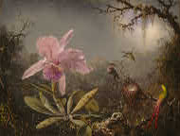  Cattleya Orchid and Three Hummingbirds  Martin Johnson Meade  1871 | Craft and Structure: 5 (see above) | Brace Map  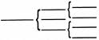  Form and Function series of Thinking Maps (Brace Map, Bridge Map, Tree Map, Multi-Flow Map)

