Name

Paralympic Games Brochure

*Directions:* You will be researching the Paralympic Games and paralympic athletes. Before you can create your brochure you will need to use the links below to research the topic. As you research an athlete or sport, complete a bubble map to record your notes. Make sure that you save your bubble maps so that you can refer back to them when creating your brochure.

Click here to open the bubble maps.

*Hold the Ctrl button while clicking links below.*

1. Click [here](http://www.london2012.com/paralympics/sports/) to open the Paralympic Games website.

Click [here](http://www2.teamusa.org/US-Paralympics/Paralympic-Athletes.aspx?athlete=&sport=9712c617-5038-4b9f-91e6-0712d646651a&alpha=&season=&page=2) to open the U.S. Paralympic website to learn more about the athletes on the team.

Click [here](http://www.timeout.com/london/feature/1319/london-2012-paralympian-interviews) to learn about athletes from Great Britain

2. Click here to open the brochure template.

3. Feel free to copy and paste one photo of your event onto the appropriate part of your brochure.

4. On the back of your brochure be sure to copy the URL of the picture location to give credit to the website for the picture. Complete directions for this are below.

Inserting pictures

1. Right-click on the picture you would like to use.
2. Left-click on copy

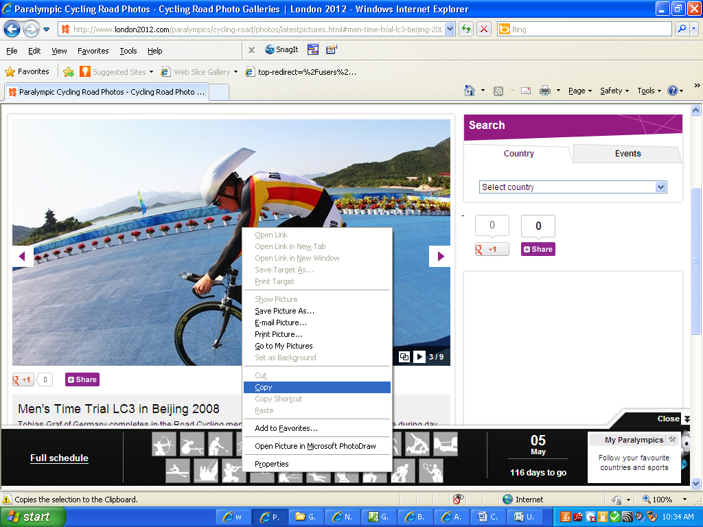

1. Go to your brochure, right-click where you would like to insert your photo and then left click on paste.

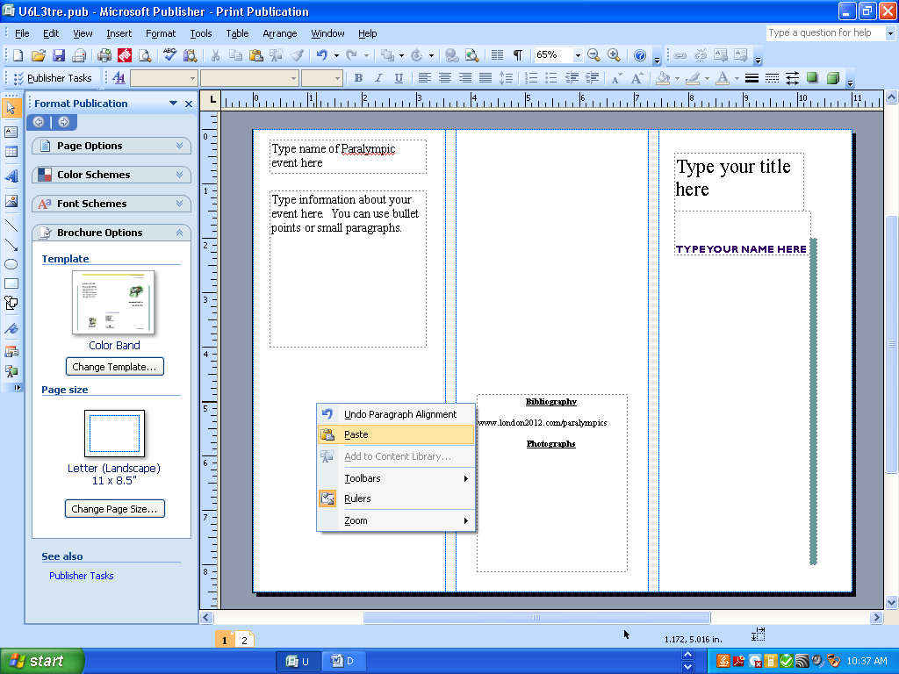

1. You will need to resize your photo to fit properly.
2. Copy the URL location of your photo so you can give proper credit.

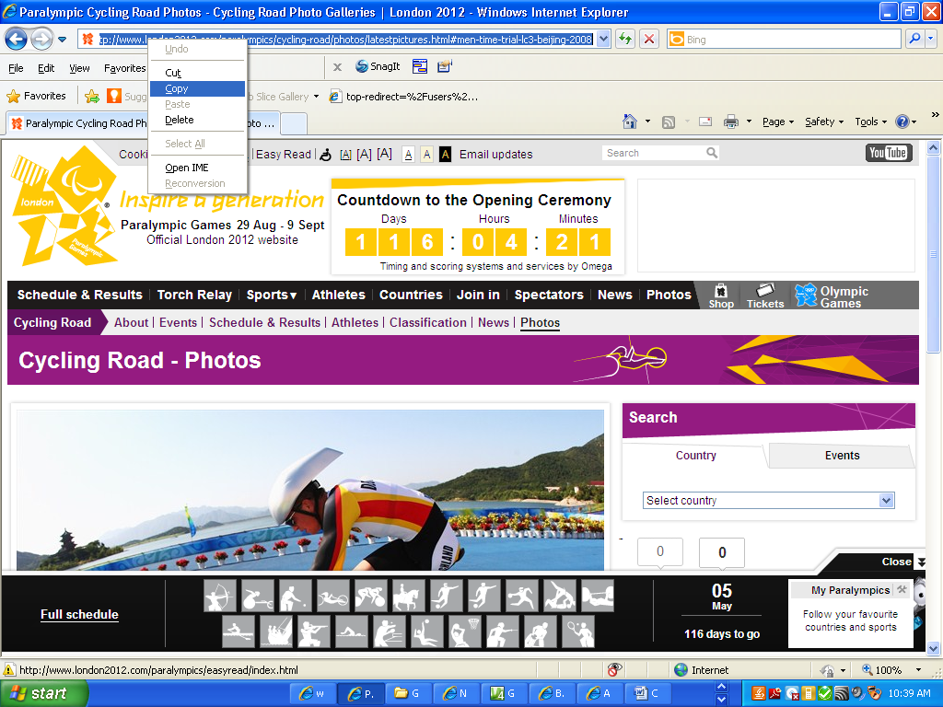

1. Right-click and paste the URL under the photographs section of your brochure.

