Legislative Branch
State and Local Legislatures

The Structure and Powers of the Maryland General Assembly
In this activity, you are going to read about the structure and powers of the state legislative branch, the Maryland General Assembly.
The purpose of the Maryland General Assembly, located in Annapolis, is to make laws for Maryland. The General Assembly meets for 90 days each year, starting in January, and considers approximately 2,300 bills including the budget for Maryland each session.

 | Structure of the Maryland General Assembly  The Maryland General Assembly consists of two separate bodies - the State Senate and the House of Delegates. The General Assembly has 188 members, with 47 senators and 141 delegates. Delegates and Senators are elected from the 47 districts in Maryland.  Each body of the Maryland General Assembly has a leader selected by its members. The President of the Senate and Speaker of the House are chosen on the first day of the session. They appoint members to committees and run the daily activities in their respective houses.

Describe the structure of the Maryland General Assembly below in your own words.

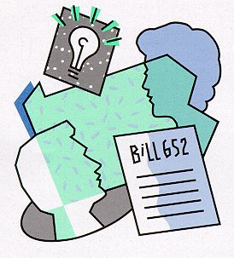  Source: www.legis.state.pa.us |  |  | Powers of the Maryland General Assembly  The main responsibility of the Maryland General Assembly is to make and pass laws. The General Assembly also has some other specific powers:  - The General Assembly approves the State's budget submitted by the Governor. The General Assembly has the final say on funds spent in the state.  - The General Assembly may choose to levy (collect) taxes.  - If an elected official has acted illegally, the House of Delegates may impeach the elected official and the Senate will hold the trial.  - The Maryland Senate approves appointments made by the Governor.
   |  |  | The real difference in lawmaking between Congress (Federal Legislative Branch) and the General Assembly is the type of laws that each passes. While Congress passes laws at the Federal Level for the United States, the General Assembly passes laws at the State Level for the state of Maryland.  Some examples of Maryland legislation deal with:  - Maryland driver's license requirements  - The Chesapeake Bay and its habitat  - Highway construction across the state  - Universities and community colleges in Maryland  - Marriage in Maryland  - Funding of public schools  - Land use and preservation in Maryland
Now that you have read the information about the Maryland General Assembly, read the statements below. Decide whether the action is the responsibility of the U.S Congress or the Maryland General Assembly and circle your answer below each statement.
- Bill passes both houses that increases funding for the military.

U.S. Congress Maryland General Assembly

- New driver’s license requirements are announced.

U.S. Congress Maryland General Assembly

- Residents must pay a new water and sewer tax.

U.S. Congress Maryland General Assembly

- Senate approves new Supreme Court justice.

U.S. Congress Maryland General Assembly

