|  |  |
| --- | --- |
| What is the title of your document? | |
|  | |
| What is the viewpoint of the document? Who would the writer of the document have been? | Is it for or against the English tax? |
|  |  |
| Were the colonists pleased with the taxes? Why or why not? | What form(s) of resistance or what actions did the colonists take, according to your document? |
|  |  |

Name______________________________________ Date___________________________

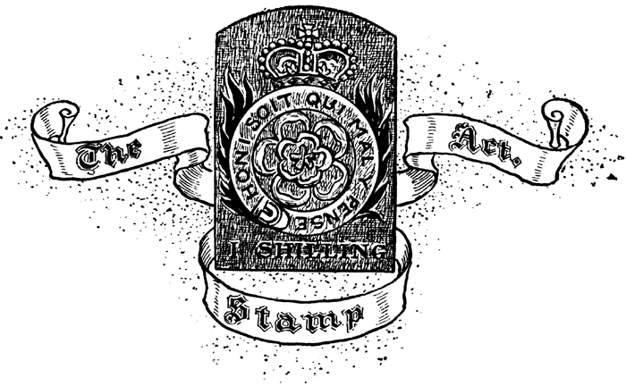**Colonial Reaction to the Stamp Act**