Artful Thinking Routines: WHAT MAKES YOU SAY THAT??
Interpretation with Justification Routine
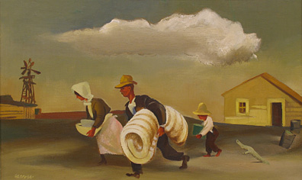
There are two core questions for this routine. The first question asks for an interpretation. The second question asks for justification.
- What’s going on?
- What do you see that makes you say that?
William Gropper
The Migration
1932
What kind of thinking does this routine encourage?
This routine helps students describe what they see or know and asks them to build explanations. It promotes evidential reasoning (evidence-based reasoning) and because it invites students to share their interpretations, it encourages students to understand alternatives and multiple perspectives. Also good for examining main idea and details.
When and where can I use it?
Because the basic questions in this routine are flexible, it is useful when looking at objects such as works of art or historical artifacts, but it can also be used to explore a poem, make scientific observations and hypothesis, or investigate more conceptual ideas (i.e., democracy). The routine can be adapted for use with almost any subject and may also be useful for gathering information on students? general concepts when introducing a new topic.
What are some tips for starting and using this routine?
In most cases, the routine takes the shape of a whole class or group conversation around an object or topic, but can also be used in small groups or by individuals. When first introducing the routine, the teacher may scaffold students by continually asking the follow-up questions after a student gives an interpretation. Over time students may begin to automatically support their interpretations with evidence without even being asked, and eventually students will begin to internalize the routine.
When using this routine in a group conversation it may be necessary to think of alternative forms of documentation that do not interfere with the flow of the discussion. One option is to record class discussions using video or audio. Listening and noting students? use of language of thinking can help you see their development. Students’ words and language can serve as a form of documentation that helps create a rubric for what makes a good interpretation or for what constitutes good reasoning.
Another option is to make a chart or keep an ongoing list of explanations posted in the classroom. As interpretations develop, note changes and have further discussion about these new explanations. These lists can also invite further inquiry and searches for evidence. Other options for both group and individual work include students documenting their own interpretations through sketches, drawings, models and writing, all of which can be displayed and revisited in the classroom.
Shared drive: Faculty: Arts Integration: Artful Thinking Strategies
http://pzweb.harvard.edu/tc/routines.cfm

