[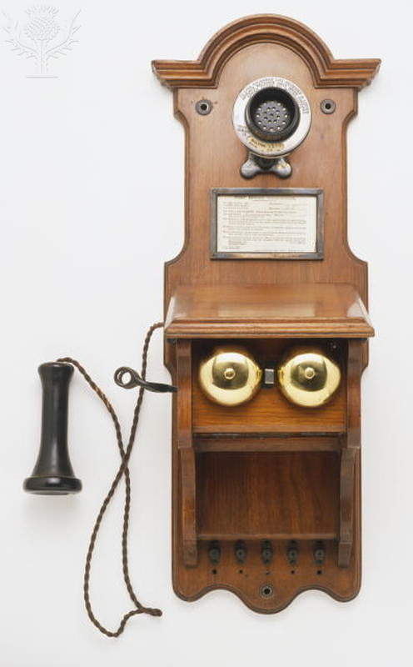](http://quest.eb.com/)

Dorling Kindersley/ Dorlng Kindersley / Universal Images Group /Rights Managed / For Education Use Only

[](http://quest.eb.com/)

Dorling Kindersley/ Dorlng Kindersley / Universal Images Group /Rights Managed / For Education Use Only

[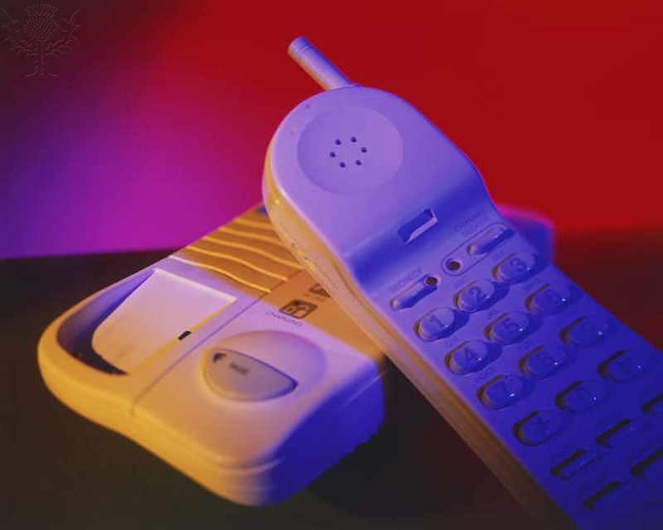](http://quest.eb.com/)

Peter Anderson / Dorlng Kindersley / Universal Images Group /Rights Managed / For Education Use Only

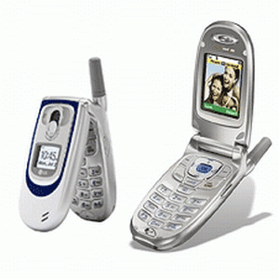https://www.urmc.rochester.edu / Rights Managed / For Education Use Only

[](http://www.google.com/url?sa=i&rct=j&q=&esrc=s&frm=1&source=images&cd=&cad=rja&uact=8&ved=0CAcQjRxqFQoTCKSt5JvI2MYCFYNUPgod-gkPxQ&url=http%3A%2F%2Fwww.riskmanagementmonitor.com%2Fthe-applesamsung-smartphone-patent-war-continues%2F&ei=PeyjVeSaDYOp-QH6k7yoDA&psig=AFQjCNHY6oBzKUPh-R4W9Q9PhwxnSLvEog&ust=1436892520639313)

http://www.riskmanagementmonitor.com/ Rights Managed / For Education Use Only

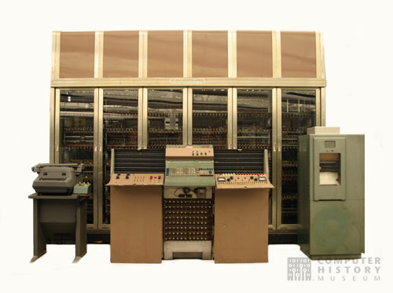

Computer History Museum / Rights Managed / For Education Use Only

[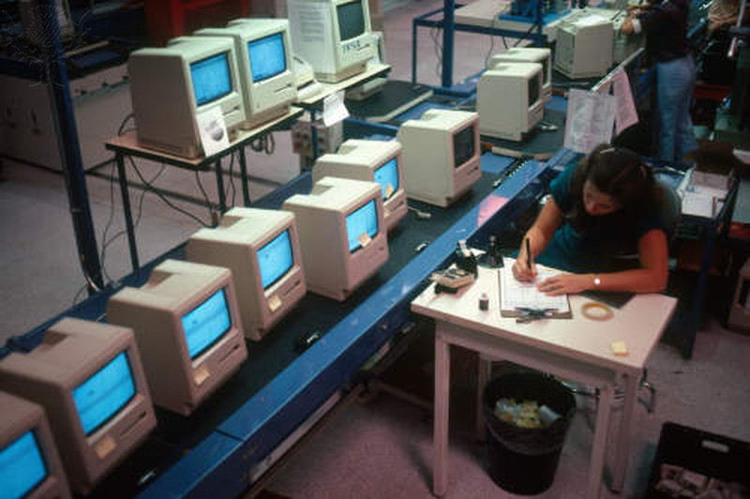](http://quest.eb.com/)

Hank Morgan / Photo Researchers / Universal Images Group /Rights Managed / For Education Use Only

[](http://quest.eb.com/)

JERRY MASON/SCIENCE PHOTO LIBRARY / Universal Images Group /Rights Managed / For Education Use Only

[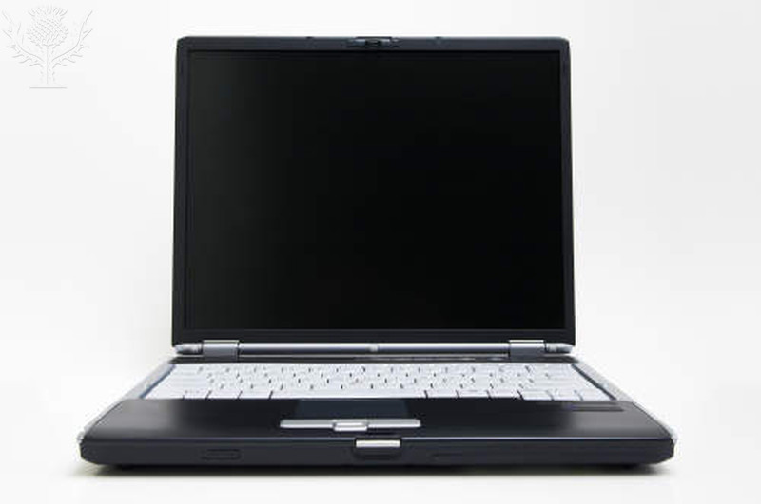](http://quest.eb.com/)

GIPhotoStock / Photo Researchers / Universal Images Group / Rights Managed / For Education Use Only

[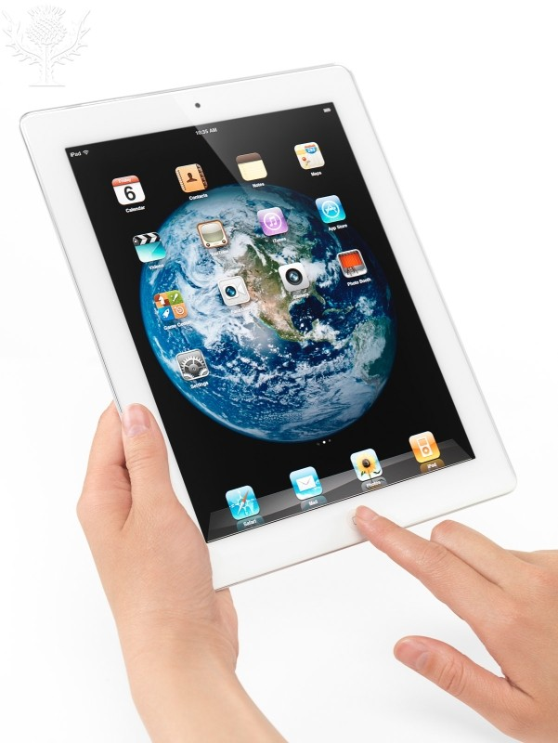](http://quest.eb.com/)

Oleksiy Maksymenko / All Canada Photo / Universal Images Group / Rights Managed / For Education Use Only

[](http://quest.eb.com/)

Andersen Ross / Blend / Learning Pictures / Universal Images Group / Rights Managed / For Education Use Only

[](http://quest.eb.com/)

Justin Sullivan / Getty Images News / Getty Images / Universal Images Group / Rights Managed / For Education Use Only