[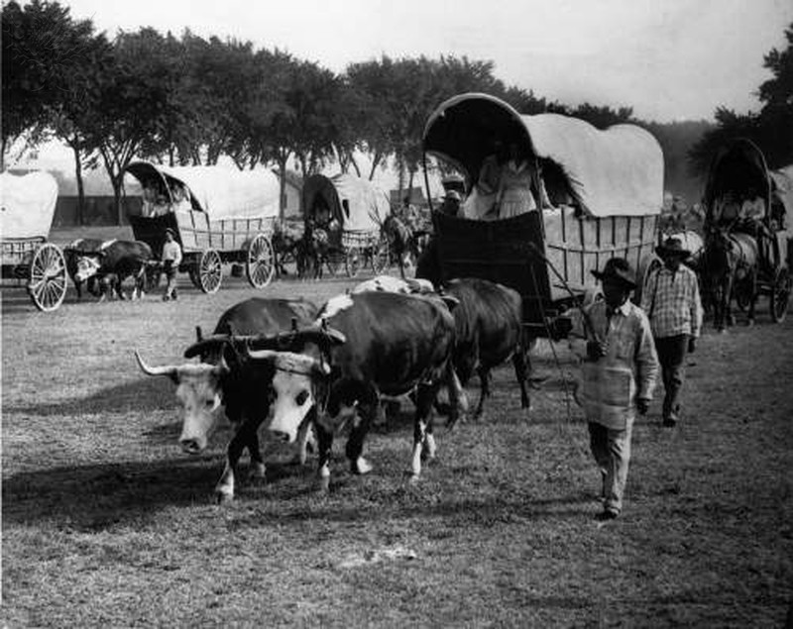](http://quest.eb.com/)

Photo Researchers / Photo Researchers / Universal Images Group Rights Managed/ For Education Use Only

[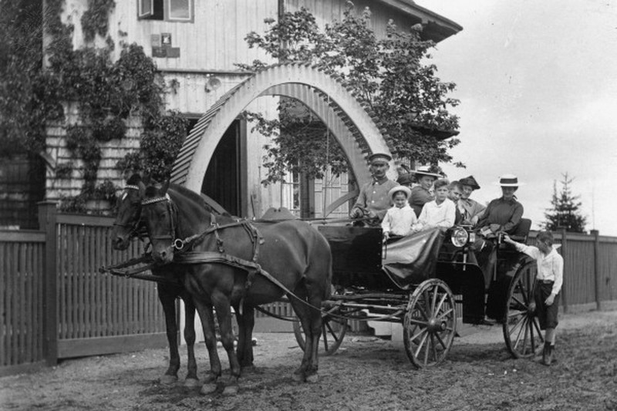](http://quest.eb.com/)

akg-images / Universal Images Group Rights Managed/ For Education Use Only

[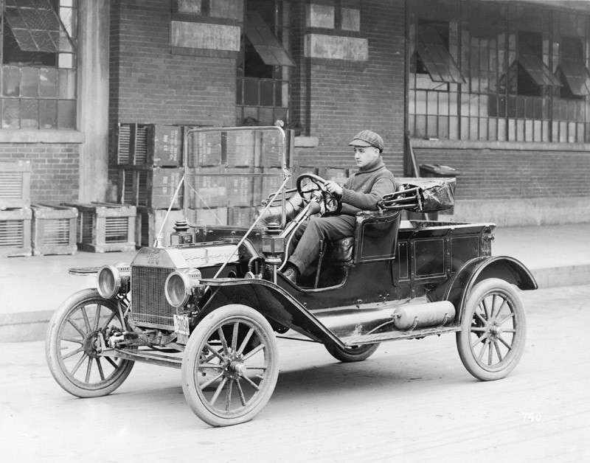](http://quest.eb.com/)

Three Lions / Hulton Archive / Getty Images / Universal Images Group Rights Managed/ For Education Use Only

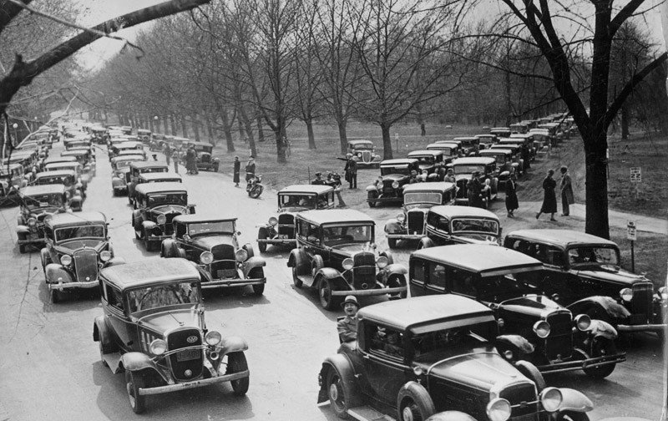

Three Lions / Hulton Archive / Getty Images / Universal Images Group Rights Managed/ For Education Use Only

[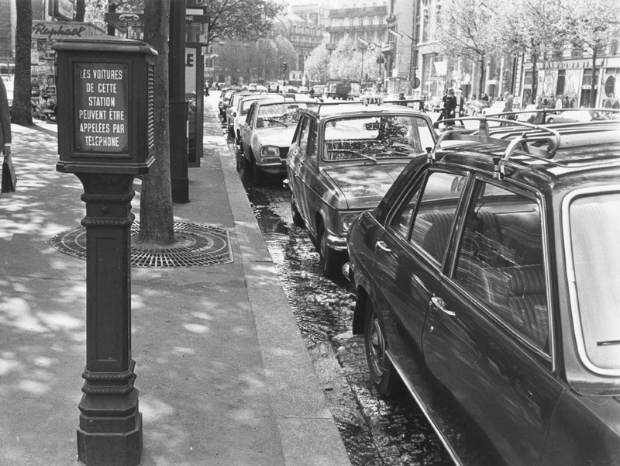](http://quest.eb.com/)

Keystone / Hulton Archive / Getty Images / Universal Images Group Rights Managed/ For Education Use Only

[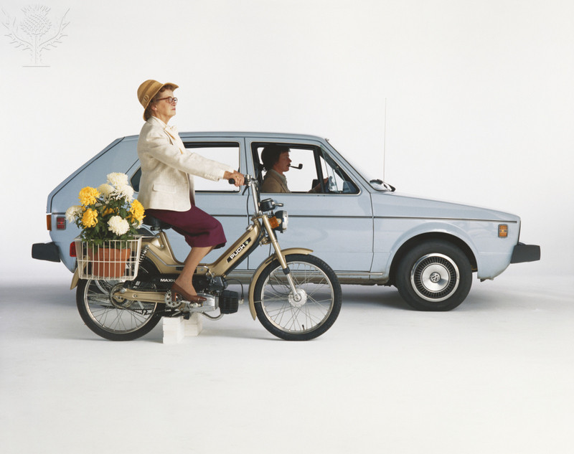](http://quest.eb.com/)

Tom Kelley Archive / Retrofile Creative / Getty Images / Universal Images Group Rights Managed/ For Education Use Only

[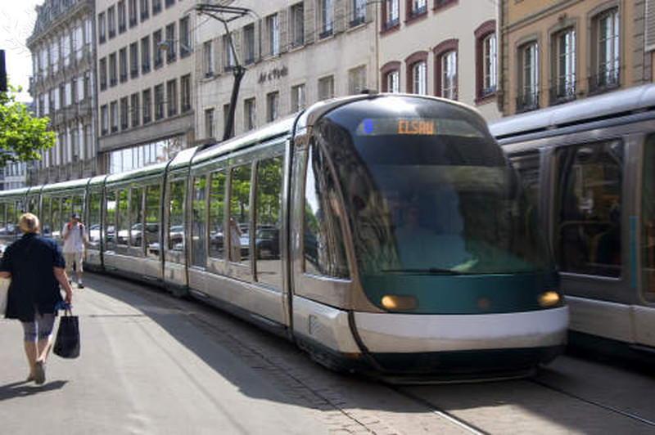](http://quest.eb.com/)

David R. Frazier Photolibrary, Inc. / Photo Researchers / Universal Images Group/ Rights Managed/ For Education Use Only

[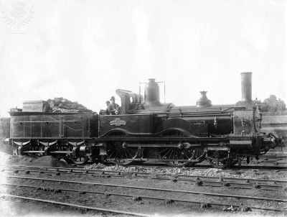](http://quest.eb.com/#/search/locomotive/1/300_2292387/London-and-South-Western-Railway-LSWR-Locomotive-No-5)

Universal History Archive/Universal Images Group / Rights Managed/ For Educational Use Only

[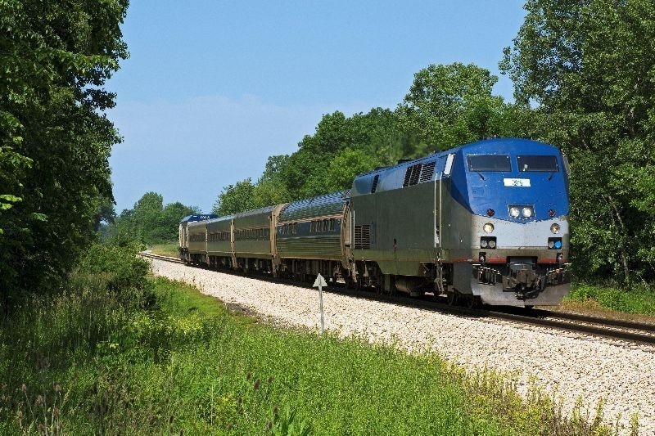](http://quest.eb.com/)

Superstock / Universal Images Group / Rights Managed/ For Education Use Only

[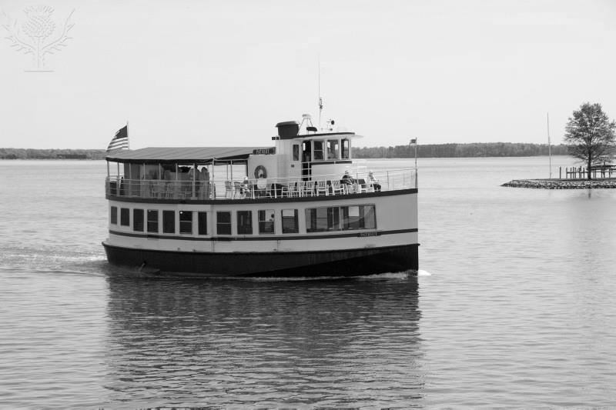](http://quest.eb.com/)

Robert Harding Productions / Robert Harding World Imagery / Universal Images Group / Rights Managed/ For Education Use Only

[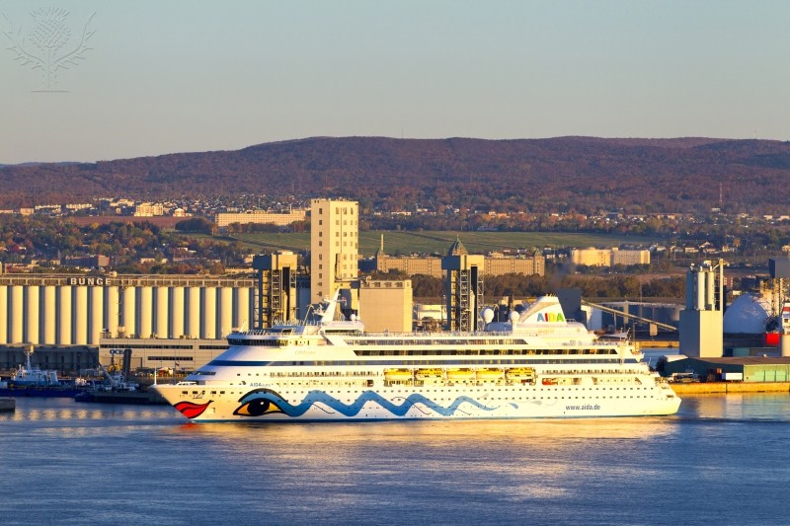](http://quest.eb.com/)

Barrett & MacKay / All Canada Photo / Universal Images Group / Rights Managed/ For Education Use Only

[](http://quest.eb.com/)

akg-images / Universal Images Group Rights Managed/ For Education Use Only

[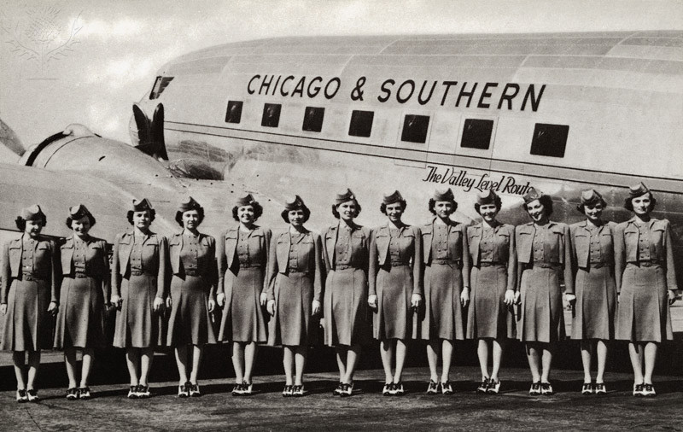](http://quest.eb.com/)

Lake County Discovery Museum / Universal Images Group / Rights Managed / For Education Use Only

[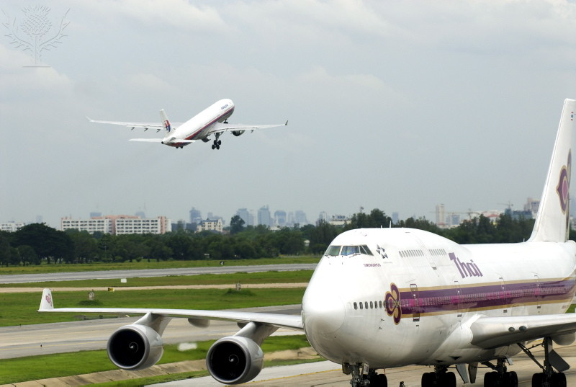](http://quest.eb.com/)

Rod Porteous / Robert Harding World Imagery / Universal Images Group / Rights Managed / For Education Use Only

[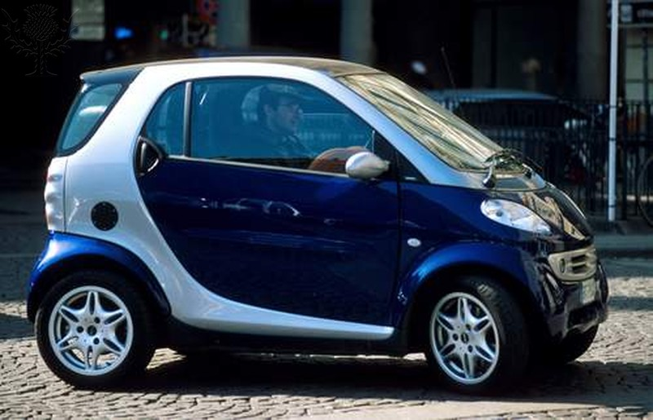](http://quest.eb.com/)

David R. Frazier / Photo Researchers / Universal Images Group / Rights Managed / For Education Use Only

[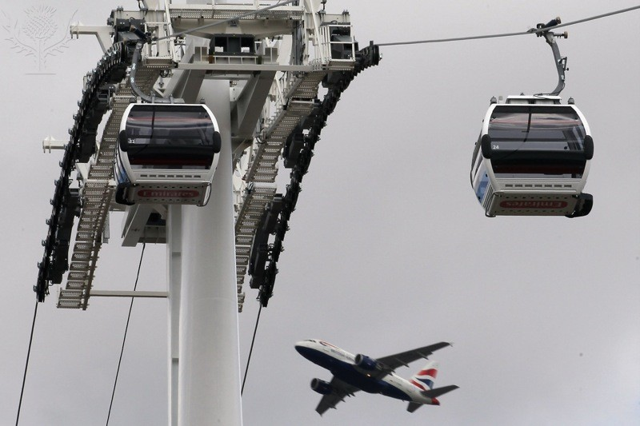](http://quest.eb.com/)

Dan Kitwood / Getty Images News / Getty Images / Universal Images Group / Rights Managed / For Education Use Only

[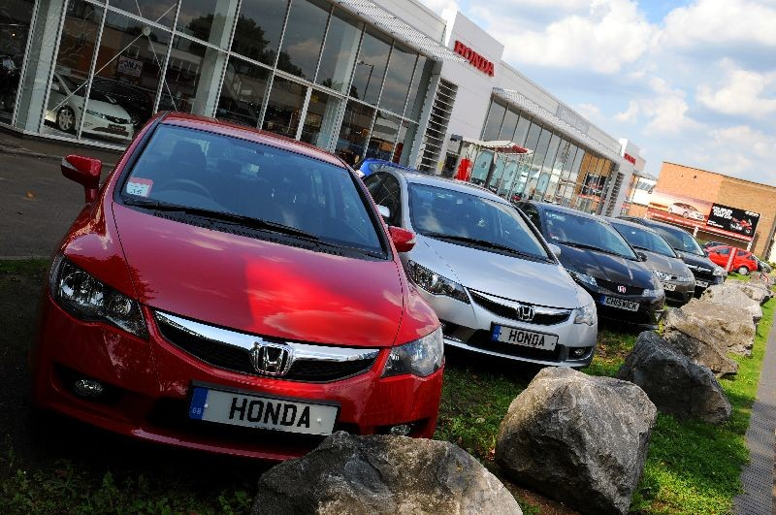](http://quest.eb.com/)

Fiona Hanson / PA Archive / Press Association Images / Universal Images Group / Rights Managed / For Education Use Only