**Conflict at the Intersection: The American Revolution**

***Directions***: Read each of the sources and determine which category ***best*** describes the point-of-view of the source. Then, record the name of each source under the appropriate category with a brief explanation.

***Background***: On the eve of the American Revolution, the colonists themselves were very much divided over how to deal with Great Britain and Parliament. At the end of the French & Indian War, Britain found itself in a lot of debt and felt that the colonists should pay their fair share of the burden for their own defense. With new taxes and the presence of British troops, some colonists were willing to break away from the mother country. However, as late as 1775, independence was by no means certain.

|  |  |
| --- | --- |
| **STOP:**  **Restore the Ties of Loyalty to Britain** | |
| C:\Documents and Settings\tejohnson\Local Settings\Temporary Internet Files\Content.IE5\HDJZDZCN\MPj03859620000[1].jpg | **What We Believe**  *No society on earth enjoys greater liberty and prosperity than the American colonies. Much of our good fortune, especially with respect to trade, is due to our status within the British Empire.* |
| **CAUTION:**  **Defend Our Rights as Englishmen** | |
| C:\Documents and Settings\tejohnson\Local Settings\Temporary Internet Files\Content.IE5\5A1EZ4Y2\MPj03859610000[1].jpg | **What We Believe**  *Taxation without representation is tyranny. Parliament has no authority over the colonies. However, the colonists should be willing to provide Britain with funds for the defense and administration of the colonies.* |
| **GO:**  **Fight for Our Independence** | |
| C:\Documents and Settings\tejohnson\Local Settings\Temporary Internet Files\Content.IE5\75D76ARZ\MPj03859600000[1].jpg | **What We Believe**  *America is strong enough to stand on her own. Disputes among the colonies will fade once we are responsible for governing ourselves. Britain has rejected all of our attempts to compromise so they have left us with no other choice.* |

**Sources**

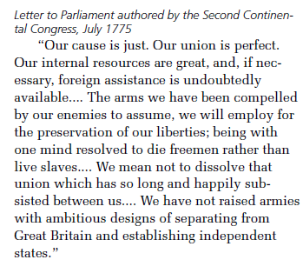

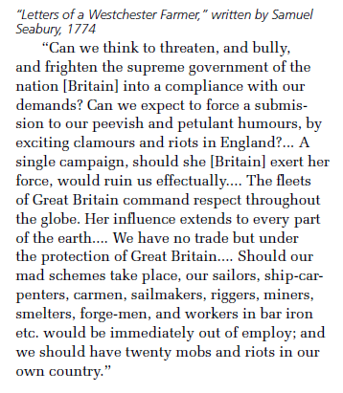

**Vocabulary**

*Highlight the following terms in each source before reading*

**dissolve:** to break up

**ambitious:** grand or bold

**subsisted**: survived

*Highlight the following terms in each source before reading*

**compliance**: agreement

**submission**: giving in

**peevish**: cranky

**petulant**: grouchy

**scheme**: plan



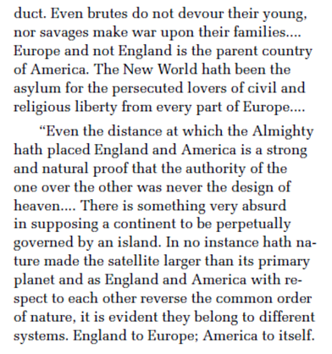

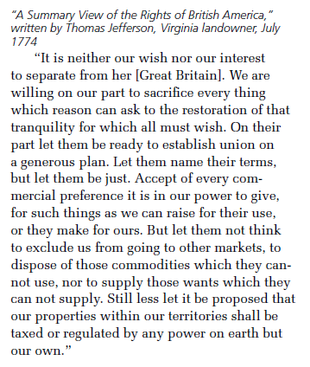

*Highlight the following terms in each source before reading*

**asylum**: place of safety

**persecuted**: mistreated

**perpetually**: forever

**evident**: clear

*Highlight the following terms in each source before reading*

**restoration**: return

**tranquility**: harmony

**commercial**: business-related

**dispose**: remove

**commodities**: goods

**Critical Thinking Questions**:

***Letter to Parliament from the Second Continental Congress***

1. Explain the meaning of the following quote in your own words:

*“We mean not to dissolve that union which has so long and happily subsisted between us…”*

***Letter of a Westchester Farmer***

1. *What had actions had the colonists taken that might have caused the author to refer to them as a “bully?”*
2. *What does the author suggest might happen if the colonists break away from Britain?*

***Common Sense by Thomas Paine***

1. *What does the author find “absurd” (silly) about the relationship between Britain and its colonies?*

***A Summary View of the Rights of British America by Thomas Jefferson***

1. *What do you know about the author?*
2. *With which of the other sources might Jefferson agree? Why?*

*Organize each source and provide a brief explanation*

|  |  |  |
| --- | --- | --- |
| **STOP:**  **Restore the Ties of Loyalty to Britain** | | |
| C:\Documents and Settings\tejohnson\Local Settings\Temporary Internet Files\Content.IE5\HDJZDZCN\MPj03859620000[1].jpg | |  |
| **CAUTION:**  **Defend Our Rights as Englishmen** | | |
| C:\Documents and Settings\tejohnson\Local Settings\Temporary Internet Files\Content.IE5\5A1EZ4Y2\MPj03859610000[1].jpg | |  |
| **GO:**  **Fight for Our Independence** | | |
| C:\Documents and Settings\tejohnson\Local Settings\Temporary Internet Files\Content.IE5\75D76ARZ\MPj03859600000[1].jpg |  | |