Maps Tell a Story

Examine each of the following maps. Then work with your group to tell a “story” of what happened from one map to the next. Identify which questions you still have about “what happened.” Share your questions with the class and then use the resources provided by your teacher to fill in the gaps in your story.

Map in 1700:

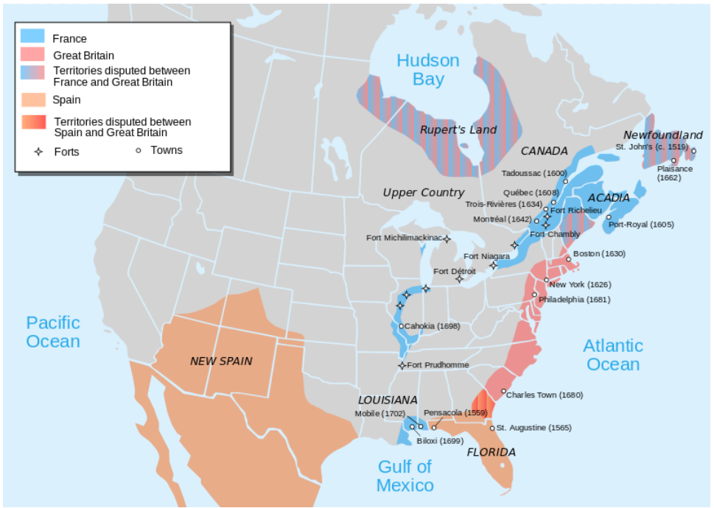

Map in 1713

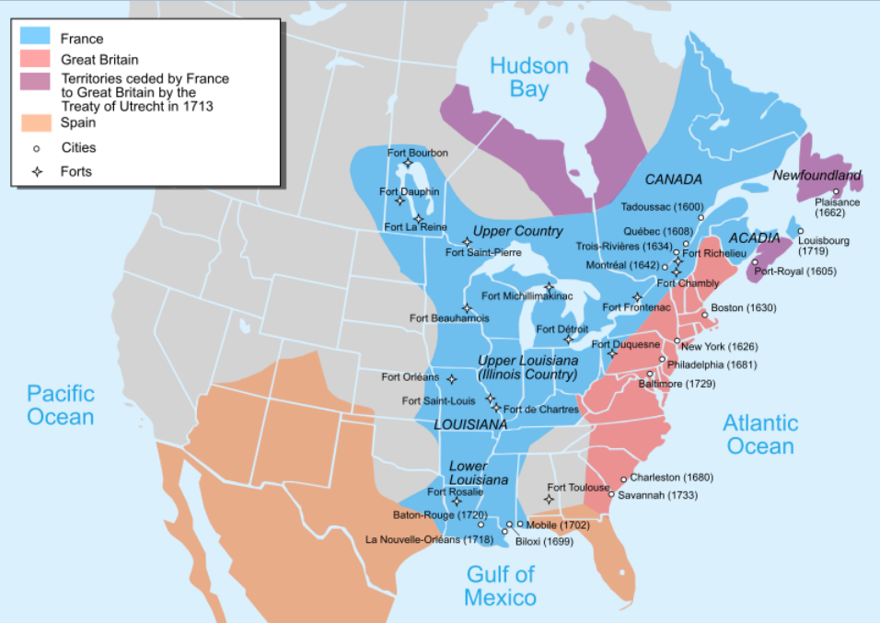

Maps in 1754 and 1763:

