**5E Required Lab – That Was Cool!**

**Volcano Pictures**

**Lava Images**

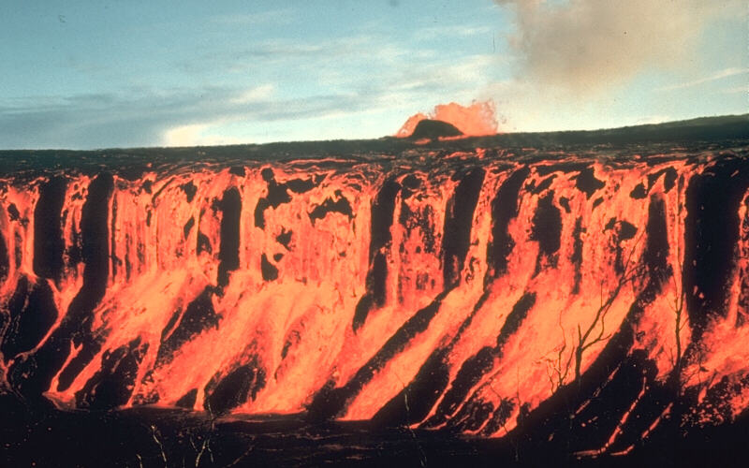

**Photgraph by D. A. Swanson, December 30, 1969.**

**(approximately 25 meter high lava cascade**

**pouring over the edge of Aloi crater in Hawaii)**

Source: [http://volcanoes.usgs.gov/images/pglossary/LavaCascade.php](https://riva.aacps.org/owa/redir.aspx?C=f1181cb380614adabc5c104ee03a1fe5&URL=http%3a%2f%2fvolcanoes.usgs.gov%2fimages%2fpglossary%2fLavaCascade.php)

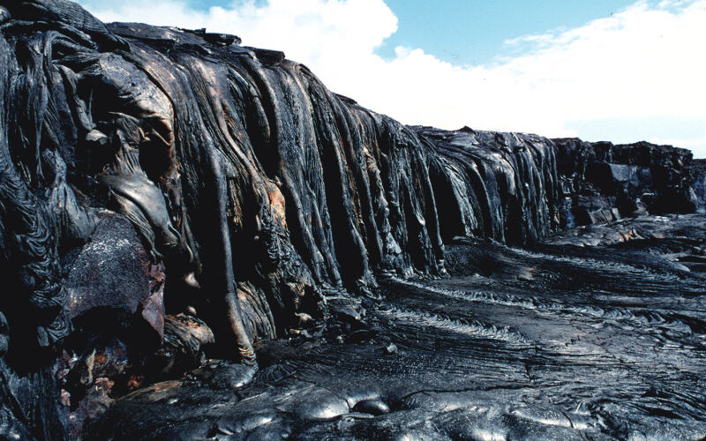

**Photograph by J. D. Griggs on April 13, 1988.**

**(lava drapery off the side of a cliff**

**near the ocean east of Kapupua Point, Kilauea Volcano, Hawaii)**

Source: <http://volcanoes.usgs.gov/images/pglossary/LavaDrapery.php>