**What's inside an antique telephone?**

They don't make them like they used to!

Take the lid off an antique phone and here's what you find:

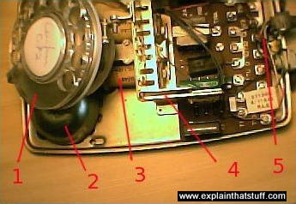

1. **Dial mechanism:** as the dial rotates, it interrupts the circuit between the phone and the exchange creating dialing pulses. If you dial number "9" you create nine pulses, dial "5" and you make five pulses, and so on.
2. **Bells:** Old phones actually had real, shiny metal bells inside them to indicate an incoming call! Modern phones have electronic buzzers or beepers, which don't sound nearly so nice.
3. **Electromagnet:** When the phone rings, this electrically controlled magnet switches on and off rapidly, moving a clapper in between the bells at the front and making them ring. It's great to watch this happening when you take the cover off. It's like being back in the 19th century!
4. **Tilting switch mechanism:** This detects when the handset is lifted or put back. If the handset rests on the switch, it cuts off the connection between the phone and the local exchange. The circuit is opened only when you lift the handset.
5. **Circuit board:** All the little wires that control different parts of the phone (the dialing, the tilt switch, and so on) meet on this circuit board.

Retrieved From: http://www.explainthatstuff.com/telephone.html