Canyon

A deep valley with very steep sides,
often carved from the Earth by a river.

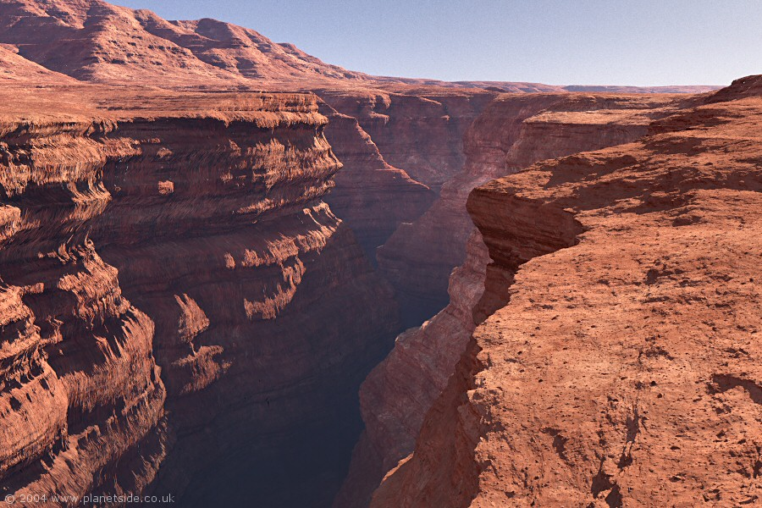

Cave

A large hole in the ground or in
the side of a hill or mountain.

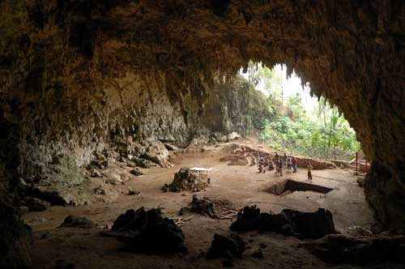
Cliff

A steep face of rock and soil.

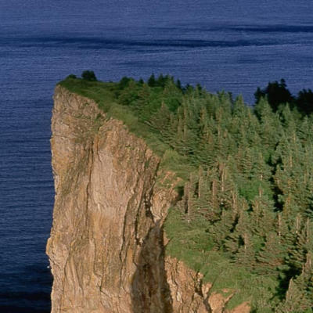

Desert

A very dry area.

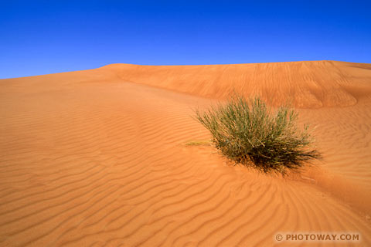

Glacier

A slowly moving river of ice.

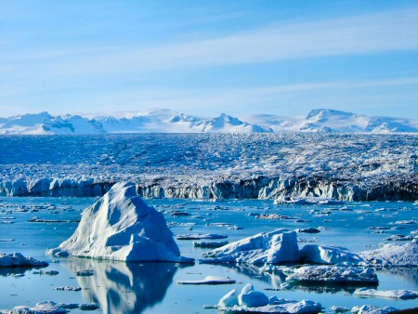

Hill

A raised area or mound of land.

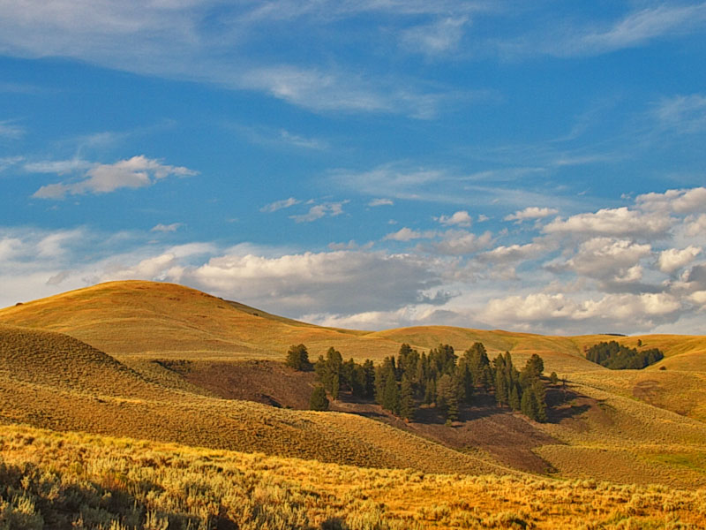
Lake

A large body of water surrounded by land on all sides.

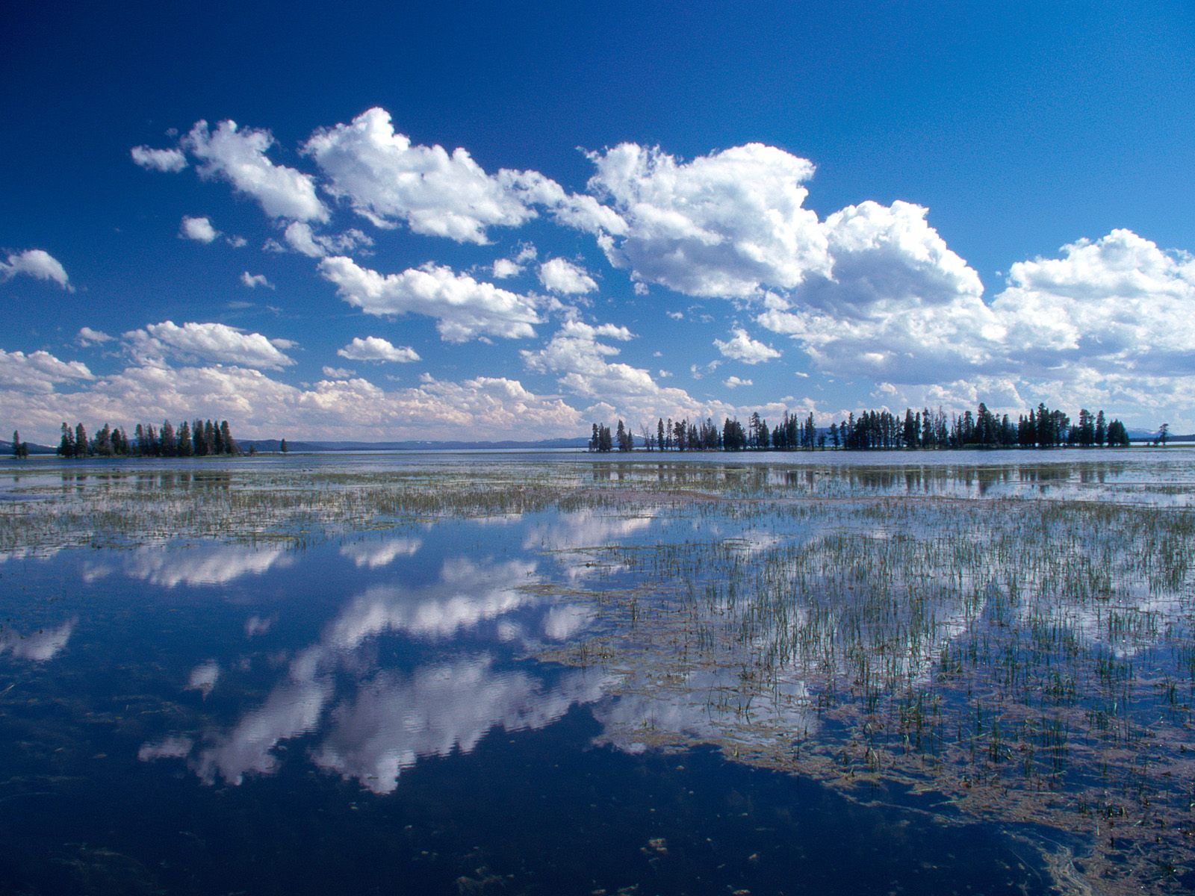

Mountain

A very tall, high, natural place on Earth,
higher than a hill.
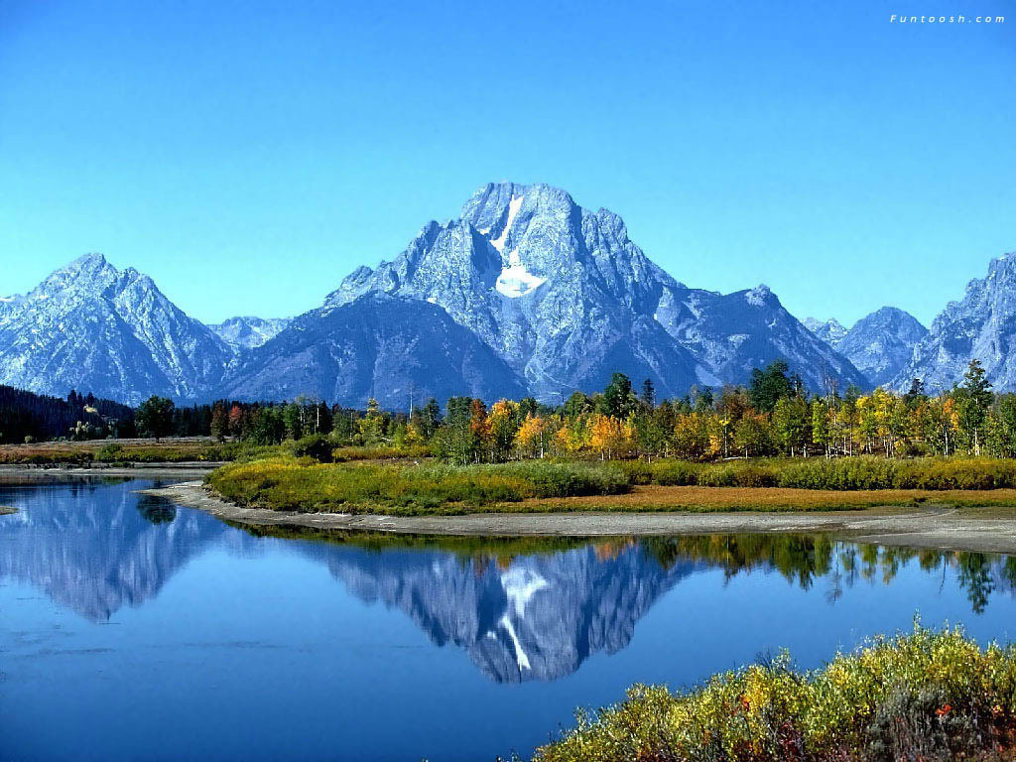
Ocean

A large body of salt water that surrounds a continent.

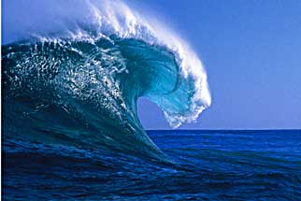

Peninsula

A body of land surrounded by water on three sides.

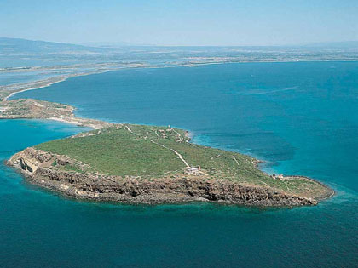

Plain

A flat land that has small change in elevation.

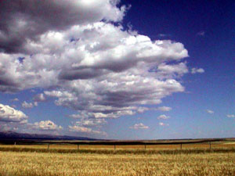

Prairie

A wide, relatively flat area of land that
has grasses and only a few trees.
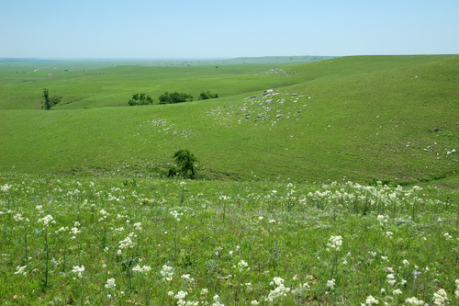
River

A large, flowing body of water which moves from higher to lower elevations.

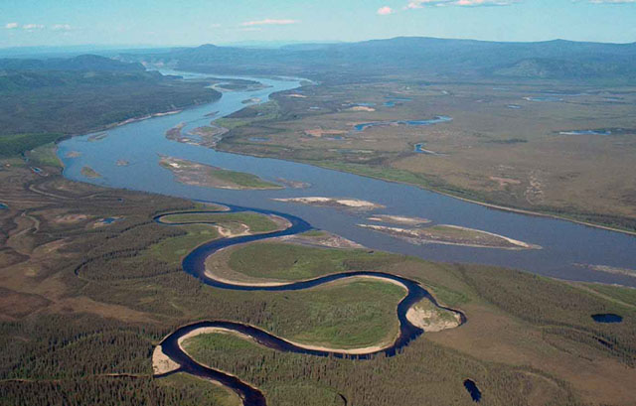
Swamp

A freshwater wetland that has spongy,
muddy land and a lot of water.

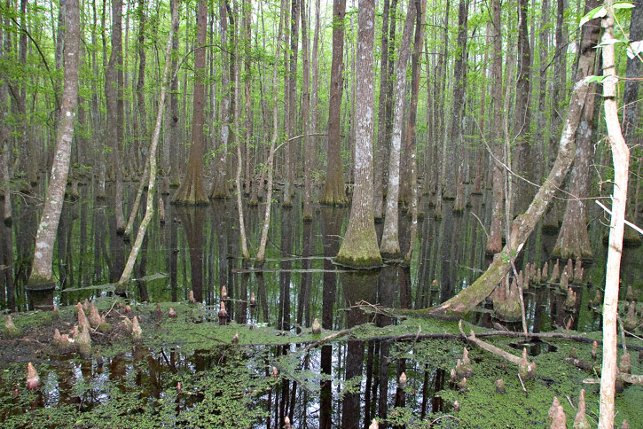
Valley

A low place between mountains.

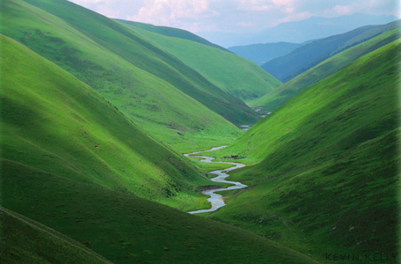

Volcano

A mountainous vent in the Earth’s crust. It erupts and spews out lava, ashes, and hot gases.

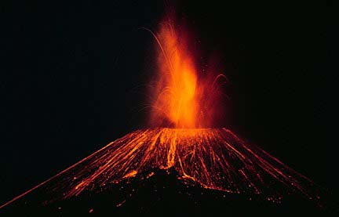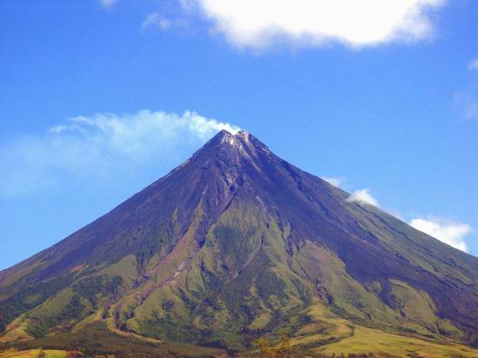

Waterfall

When a river falls off steeply.

