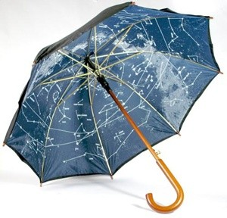Apparent Motion of the Stars

Materials:

Black construction paper or black umbrella (dollar store)

Glow in the dark stickers, white out or other material to make stars on construction paper or umbrella

Star Movement Lesson (demonstration of apparent motion with sky umbrella)

1. Ask the students “Do the stars move?”
2. “Why can the constellations be seen in different locations at different times of the night?”
3. The stars seem to drift across the sky at night because the Earth is turning on its axis. During each 24-hour period, the part of the Earth you are on turns so that you are facing different parts of space.
4. You can demonstrate this by making a model of the sky on the underside of an umbrella. Stick some glow-in-the-dark stars on the underside of an umbrella to form a few well known constellations.
5. Place a sticky dot on a globe where Georgia is located to show where we are standing as we view the night sky.
6. Have one student hold the globe and turn it slowly to simulate the Earth’s rotation on it axis.
7. Have another student hold the umbrella stationary over the globe. Help students observe that the dot on the globe faces different parts of the sky (umbrella) as the globe turns.
8. Ask the students, “Why is it important that we keep the umbrella still while the globe turns?” (Stars do not move; only the Earth is moving.)
9. **Home Activity:** Ask student to try this experiment to show how a star seems to drift across the sky at night. Pick out a bright star and stand somewhere so that it lines up with an immobile landmark, such as a tree. Note the time and return to the same spot an hour later. You will find that the star has moved to the west of the landmark. If you look at the same star over the next few days, you will find that it will line up with your landmark four minutes earlier each night.