Comparing Rocks and Minerals

Number of class periods: One

Maryland VSC Standards:
Materials and Processes That Shape a Planet

2.5. A.3.b. Identify and compare the properties of rocks that are composed of a single mineral with those of other rocks made of several minerals using their physical properties.

Student Outcome(s)
The student will compare the physical properties of rocks and minerals.

Background knowledge / teacher notes:
The whole earth is made of rocks & minerals. Inside the earth there is a liquid core of molten rock and on the outside there is a hard crust. If you compare the earth to an egg, the shell on an egg is like the crust on the earth. The crust is made up of rocks and minerals. Much of the crust is covered by water, sand, soil and ice. If you dig deep enough, you will always hit rocks.
Below the loose layer of soil, sand & crumbled rocks found on Earth is bedrock, which is a solid rock.

The rocks you see around you - the mountains, canyons & riverbeds, are all made of minerals. A rock is made up of 2 or more minerals. Think of a chocolate chip cookie as a rock. The cookie is made of flour, butter, sugar & chocolate. The cookie is like a rock and the flour, butter, sugar & chocolate are like minerals. You need minerals to make rocks, but you don't need rocks to make minerals. All rocks are made of minerals.

When rocks break down into smaller & smaller pieces, they turn into sand. If you look at the sand under a microscope, you will see that sand is made up of the same minerals as the rocks that the sand came from. When plants start to sprout up in sand, it is turning from being just small bits of rock to being soil.

Rocks are constantly being formed, worn down and then formed again.
This is known as the Rock Cycle. It is like the water cycle but it takes a lot longer. It takes thousands and millions of years for rocks to change. Rocks are divided into 3 Types. They are classified by how they were formed: igneous, sedimentary, and metamorphic. Fifth graders do not need to know the three different types of rock, but many of them will have prior knowledge about rocks. It is important to tell them that there are three types, but you do not need to go into detail.
Misconceptions: Students do not know the difference between a mineral and a rock. They assume everything is a rock. However, now that they have finished studying minerals, when they look at rocks, they should start to see that there are minerals inside of a rock’s composition.
Students often want to know if geodes are rocks or minerals. Geodes are actually minerals that grow inside of rocks. There are many theories to explain how geodes actually form. Many students or their parents own geodes that they bought at museums or stores. This unit on minerals and rocks are a good time to allow students to share samples they have. As they become more knowledgeable about the difference between rocks and minerals, they can start to identify the minerals within rocks and perhaps create their own theory of what are geodes and how do they form.

Lesson Description:
Day 1
ENGAGE | Read “If you Find a Rock” by Peggy Christian.  Or  “Everybody Needs a Rock” by Byrd Baylor  Discuss rocks that students have found. What made them special?  Teacher note: You may want to ask students ahead of time to bring in their favorite rock to share with the class on this day.  Pass out rocks in pairs and have students find the person with their matching rock. This will become their lab partner for this activity. You have pass out more than 2 of the same rocks and have larger groups.  Allow time for them to examine their rock and discuss their observations.
EXPLORE | Pass out a set of rocks to each pair. Have them sort the rocks into three different groups and create classifications of each group. Have students use a Tree Map to defend their reasoning for their classifications.
EXPLAIN | You Rock! Sheet. Create a class definition of a rock based on their observations.  A rock is any naturally formed solid in the crust that is made up of two or more minerals.  Create a Thinking Map comparing rocks and minerals.
EXTEND | Pet Rock Posters
EVALUATE | Exit Ticket on Rocks

Look at the rocks that your group has been given. Classify the rocks into three different groups based on similar characteristics. When you finish, name each group.

Group 1: _____________________

Group 2: ____________________

Group 3: ____________________

Name _____________________________ Date _________________________
You Rock!

What is a rock?

__________________________________________________________________________________________________________________________________________________________________________________________________________________________________________
Create a Thinking Map to compare Rocks and Minerals.

Name _____________________________ Date _______________________

Pet Rock Posters

Have you ever heard of a pet rock? In 1975, a business man in California came up with the idea of selling rocks as pets. He considered dogs, cats, and birds too messy and expensive to keep, and instead advertised his Pet Rock as the ideal pet. The Pet Rock was packaged in a box that looked like a pet carrying case, and even came with a “Pet Rock Training Manual.” Topics included “How to Make Your Pet Rock Roll Over and Play Dead” and “How to House-Train Your Pet Rock.” Believe it or not, the Pet Rock became a huge hit and the salesman became rich.

Your task is to create an advertisement for a Pet Rock. You may choose any rock in your Rocks and Minerals guide book. Give your rock a clever name and then design an ad to sell the rock.

Your ad must include:
- A detailed description of the Pet Rocks Properties (Including mass, length, width, color, texture, and luster).
- A labeled, detailed, full color drawing of the Pet Rock showing its unique features.
- Two suggested uses for the Pet Rock based on its properties.
- A creative statement to make people want to buy the Pet Rock.
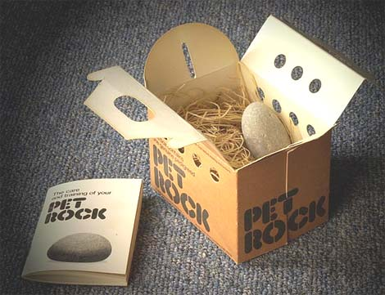
**Extra Credit: A poem, song, rap, jingle, drawing of the rock’s package, or “training tips” for the Pet Rock.

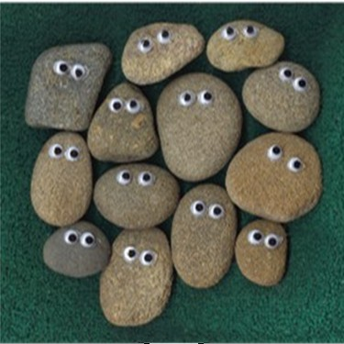
Pet Rock Advertising Poster Rubric

Your name _________________________ Pet Rock’s Name __________________

Your poster includes:

4 Points: A detailed description of the Pet Rocks Properties (Including mass, length, width, color, texture, and luster).

4 3 2 1 0

3 Points: A labeled, detailed, full color drawing of the Pet Rock showing its unique features.

3 2 1 0

2 Points: Two suggested uses for the Pet Rock based on its properties.

2 1 0

1 Point: A creative statement to make people want to buy the Pet Rock.

1 0

Extra Credit: A poem, song, rap, jingle, drawing of the rock’s package, or “training tips” for the Pet Rock.

1 0

Total Points: ________________ out of 10
Name _____________________ Date _______________
Rocks Exit Ticket

Compare a rock to a mineral.

________________________________________________________________________________________________________________________________________________________________________________________________________________________________________________________________________________________________________________________________________________________________________________________________________________________________________
3
The answer is clear, complete, and correct. It gave many details about the similarities and differences between rocks and minerals
2
The answer is correct. It gave some details about the similarities and differences between rocks and minerals
1
The answer is on the right track. It should have given more details about the similarities and differences between rocks and minerals
0
The answer is incorrect, or it didn’t have anything to do with the question.

