**Water Filter Procedure**

Create Water Filter:

1. Place the funnel on top of the clear container. The top half will be the **filter** and the bottom half will hold the **filtered water**.
2. **Layer the filter materials** (sand, gravel, napkins, cotton balls, etc.) inside the top half of the bottle.
3. Record the filter makeup on the Data Sheet.
4. Obtain a cup of polluted ‘Bay’ water, make observations on color, materials in the water and smell.
5. **Predict** what type of “pollution” might be removed by each layer of the filter materials.

Filter Your Water and Make Observations:

1. **Pour** the polluted water through the filter.
2. **Observe** what the filtered water looks like.
3. Observe a classmates filtered water and determine if your water is ‘cleaner’ than theirs. Observe how their filter is made.
4. **Take apart** your filter and look at each of the different layers. Can you tell what each material filtered from the water?

Try it Again:

1. Empty the bottle, throw out the filter materials, and wipe out the bottle.
2. Try it again! See if you can make the filtered water even cleaner! Try putting materials in different layers or try using different amounts of each material based on what you learned from your own and your classmates filter.
3. Record your observations on the Data Sheet.

Environmentalist’s Name ________________________

**Clean U** **p Your Mess Lab Worksheet**

**[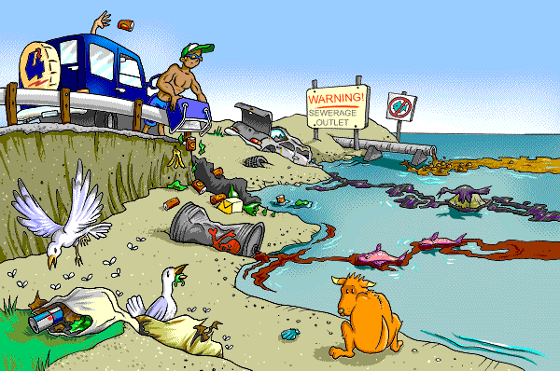](http://www.michellehenry.fr/yuckybeach.gif)**

**Identify the Problem: (Question)**

How can pollutants be filtered from water?

**Form the Hypothesis: (Prediction)**

**____________________________________________________________________________________________________________________________________________________________________________________________________________________________________________________________________________________________________________________________________**

Make Your Water Filter:

1. Draw and label the layers

in your filter on the image:

**Materials:**

**Procedure: (Directions)**

1. Place the funnel on top of the clear container. The top half will be the **filter** and the bottom half will hold the **filtered water**.
2. **Layer the first filter material**  inside the funnel.
3. Measure 60 ml of polluted water using the graduated cylinder.
4. Pour the polluted water through the first filter material.
5. Make observations on color, smell, clarity, and materials in the water.
6. Pour the polluted water back into the graduated cylinder.
7. Measure the amount of water lost in milliliters.
8. Repeat steps 2-7 for your next filter layer.

|  |  |  |  |
| --- | --- | --- | --- |
| **Observation before filtering:** | | | |
| **Layers** | **Material** | **Observation after filtering**  **(color, smell, clarity, materials removed?)** | **Loss of water?** |
| **Filter Layer 1** |  |  |  |
| **Filter Layer 2** |  |  |  |
| **Filter Layer 3** |  |  |  |
| **Filter Layer 4** |  |  |  |

**Analyze the Data:**

Draw and label the layers in your filter.

1. Which layer removed the most pollutants? How do you know?

________________________________________________________________________________________________________________________________________________________________________________________________________________________________________________________________________

**Write the Conclusion:**

1. How clear is the water after you have filtered it? Does this water seem like it could be drinkable? Why or why not?

______________________________________________________________________________________________________________________________________________________________________________________________________

1. Create a scale that others could use to measure how polluted a body of water has become. Explain how your scale would work. Then use your scale to rate how well your water sample was filtered.

|  |  |  |
| --- | --- | --- |
| Self-Assessment  3 2 1  Excellent---Satisfactory---Needs Improvement | Studant Evaluation | Teacher Evaluation |
| I created a hypothesis using the If…Then…Because method. |  |  |
| I followed all of the steps of the procedure correctly to create the water filter and worked well with my group. |  |  |
| I recorded all of my data accurately and with detail on my data chart. |  |  |
| I analyzed my data to determine which material would be the best to use as a water filter for pollutants and justified my reasoning. |  |  |
| I designed my own water pollution scale and explained how the scale works. |  |  |

Look at another classmates water and filter.

Repeat the experiment based on your observations and record.

**Clean Up Your Mess Lab Worksheet**

2nd Experiment

Make Your Water Filter:

Draw and label the layers

in your filter on the image:

Write your predictions of what type of “pollution” might be removed by each layer of the filter materials:

|  |  |  |  |
| --- | --- | --- | --- |
| **Layers** | **Material** | **Predict which Pollution gets Filtered Out** | **Observe Pollutants in Filter. *Were You Correct?*** |
| **Filter Layer 1** |  |  |  |
| **Filter Layer 2** |  |  |  |
| **Filter Layer 3** |  |  |  |
| **Filter Layer 4** |  |  |  |

Filter Your Water and Make Observations:

Write your observations of the filtered water here:

It looks: _________________________________________________________________

Color: _____________ How Clear is the Water?: _____________ Smell: ____________

Does this water seem like it could be drinkable?: __________________________________

Which of the two filters worked the best?________________________________

Which material worked the best? _____________________________________