**How Do We Use Maryland’s Resources?**

# Number of Class Periods: Two

**Maryland VSC Standards:**

**Natural Resources and Human Needs**

***6.5.A.1.a.*** ***Identify and compare Maryland’s renewable resources and nonrenewable resources.***

***6.5.A.1.b. Describe how humans use renewable natural resources, such as plants, soil, water, animals.***

***6.5.A.1.c.*** ***Describe how humans use nonrenewable natural resources, oil, coal, natural gas, minerals, including metals.***

**Student Outcome(s)**

The student will identify and compare Maryland’s renewable resources and nonrenewable resources.(Day 1)

The student will describe how humans use renewable and nonrenewable natural resources. (Day 2)

**Background knowledge / teacher notes:**

A renewable resource is a living or nonliving resource that can be replaced naturally**.** Examples: trees, fish, water, wind, sun, etc. It is possible to use populations of living things faster than they can reproduce. Once completely gone, a living thing cannot be replaced (i.e. extinct animals).

A nonrenewable resource is one that can be used up faster than it is made. It takes millions of years to make oil, natural gas, and coal, but we can use up these resources in only hundreds of years.

\*\*Renewable resource (can be replenished, such as trees and plants) and non-renewable resources (can be depleted, such as coal, oil, and minerals)

**Misconceptions:** Students often believe that sunlight or the sun is a nonrenewable resource. However the sun is a renewable resource for it will not be depleted within their lifetime (millions of years).

**Connection**: Fifth grade social studies teachers also teach resources. Talk to the social studies teachers on your team to collaborate on this lesson.

Lesson Description:

|  |  |
| --- | --- |
| **Day 1** | |
| **ENGAGE** | Hand out one natural resource cards to several different students. Explain to students that each card is an illustration of resource found in the state of Maryland.  Using two students, separate students into two groups (nonrenewable and renewable – see key), based on their resource, without telling students why you have separated them. |
| **EXPLORE** | 1. Have the class hypothesize the classification of each group. List ideas on the board or overhead. 2. Choose another two students and have students check their hypothesis and modify if necessary. Students should be completing their organizer as you work as a class. 3. Continue the process until all students have been grouped. |
| **EXPLAIN** | Lead students to identify that some resources are renewable or recyclable and the others are not.  *Students should have listed under Group 1 and Group 2 the correct identification for each grouping as nonrenewable and renewable based on the class activity. Be sure to discuss the renewable resources that could be depleted.* |
| **EXTEND** | 1. Distribute Maryland’s Resources Map. Have students observe where renewable and nonrenewable resources in Maryland can be found. On a black and white copied map, have students highlight on the keep and on the map the nonrenewable resources that can be found in Maryland. 2. (Teachers should if possible print out and laminate color maps -from Minerva-for each student for this activity to make it easier for students to read) 3. Ask students to draw conclusions about where the different types of resources are located within the state. 4. Have students make comparisons about the resources in MD.  * Renewable versus nonrenewable? * Most abundant renewable vs. least abundant? * Most abundant nonrenewable vs. least abundant? * Regions (Type of land, as well as, east, west, south and north portions of the state) where resources’ are located and why? (i.e. manufacturing = urban area) * Which region is most commonly found in Maryland and why?   Allow the students to use the map to answer questions related to the resources. |
| **Evaluate** | *Journal Write*: Create a Double Bubble Thinking Map and/or explain the difference between a renewable and nonrenewable resource. |

|  |  |
| --- | --- |
| **Day 2** | |
| **Engage** | Read “The Giving Tree” by Shel Silverstein.  As a class list all the ways the tree is used by the young boy.  Use this list to review the word resource. |
| **Explore** | Human uses of Maryland’s Resources  1. Model how to complete either option (below) using natural gas as the resource.  Examples: General: heating home and cooking  Specific: gas fireplace, light stoves, run furnace, etc…  (See key for suggested student responses.)  Option 1:(Recommended due to time constraints)  Separate students into small groups (8 groups)  Hang up/place 8 posters with each of the natural resources: plants, animals, water, wood, soil, oil, coal, and minerals  Using a timer, allow each group to visit each poster and add their own ideas of how humans use each resource.  Save enough time to quickly discuss some of the ideas expressed by the class for each resource.  Option 2:  Separate students into small groups (8 groups) and assign each group a natural resource. (Plants, animals, water, wood, soil, oil, coal, and minerals.)  Have students create a web of how humans use the assigned resource.  Have each group share their web. |
| **Extend** | Complete “How do we use our resources?” chart together |
| **Evaluate** | Maryland’s Resources Assessment |

Name \_\_\_\_\_\_\_\_\_\_\_\_\_\_\_\_\_\_\_\_\_\_\_\_\_\_\_\_\_\_\_\_\_\_ Date \_\_\_\_\_\_\_\_\_\_\_\_\_\_\_\_\_\_\_\_\_\_\_

**How do we use our resources?**

|  |  |
| --- | --- |
| **Resources** | **How do we use it** |
| **Plants**  **MCj02322350000[1]** |  |
| **MCj02873740000[1]Animals** |  |
| **Water**  **MCj02331100000[1]** |  |
| **Wood**  **MCj02395470000[1]** |  |
| **MCHH02200_0000[1]Soil** |  |
| **Oil**  **MCj03198020000[1]** |  |
| **MCj03525880000[1]Coal** |  |
| **Minerals**  **MCj02413110000[1]** |  |

|  |  |  |
| --- | --- | --- |
| **Maryland Resources Appendix Page** | | |
| Cattle  AN04294_ | Fruit  FD01101_ | Potatoes  j0112420 |
| Clay  dd00574_ | NA01296_Hogs | an01918_Poultry |
| CoalIN00480_ | Limestone | Soybeans |
| Corn | Manufacturing | Sweet potatoes |
| CrabsBD06322_ | Melonsj0079105 | j0279168Tobacco |
| j0411890Dairy | Natural gas  sy00607_ | Vegetables  j0113144 |
| j0238929Fish | Oysters  fd01106_ | Wheat  j0149540 |

**Teacher’s Key**

# *Maryland’s Natural Resources*

|  |  |  |
| --- | --- | --- |
| Group 1: RENEWABLE | Group 2:  NONRENEWABLE | Hypothesis |
| CATTLE | CLAY |  |
| CORN | COAL |  |
| CRABS | LIMESTONE |  |
| DAIRY | NATURAL GAS |  |
| FISH | MANUFACTURING |  |
| FRUIT |  |  |
| HOGS |  |  |
| MELONS |  |  |
| OYSTERS |  |  |
| POTATOES |  |  |
| POULTRY |  |  |
| SOYBEANS |  |  |
| SWEET POTATOES |  |  |
| TOBACCO |  |  |
| VEGETABLES |  |  |
| WHEAT |  |  |
|  |  |  |
|  |  |  |

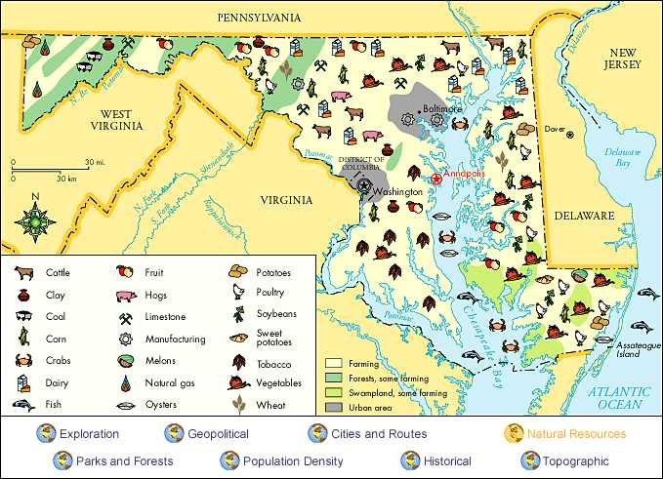

Name \_\_\_\_\_\_\_\_\_\_\_\_\_\_\_\_\_\_\_\_\_\_\_\_\_\_\_\_\_\_ Date \_\_\_\_\_\_\_\_\_\_\_\_\_\_\_\_\_\_\_

###### **Maryland’s Resources**

***Directions:*** Use the map of Maryland’s Natural Resources to answer the following questions.

1. Maryland’s first major source of wealth was its tobacco crop. In what part of the state is tobacco still a major crop?
2. East of Baltimore

##### North of Baltimore

1. North of Washington
2. South of Washington
3. The Chesapeake Bay and the nearby Atlantic Ocean are important to Maryland’s economy. Which renewable resource is ***NOT*** found in the Chesapeake Bay and the Atlantic Ocean?
4. Soy beans
5. Oysters
6. Crabs
7. Fish
8. Based on the map, what is most likely true about Maryland’s Eastern Shore?
9. The Eastern shore is abundant in nonrenewable resources.
10. The Eastern shore is a good place for a waterman.
11. The Eastern shore is a good place for a cattle farmer.
12. The Eastern shore is abundant in mining resources.
13. What is a nonrenewable resource produced in an urban area?
14. Limestone
15. Coal
16. Natural Gas
17. Manufacturing
18. Which nonrenewable resources are found in the western part of Maryland?
19. Clay and Fruit
20. Clay and Limestone
21. Coal and Natural Gas
22. Coal and Potatoes

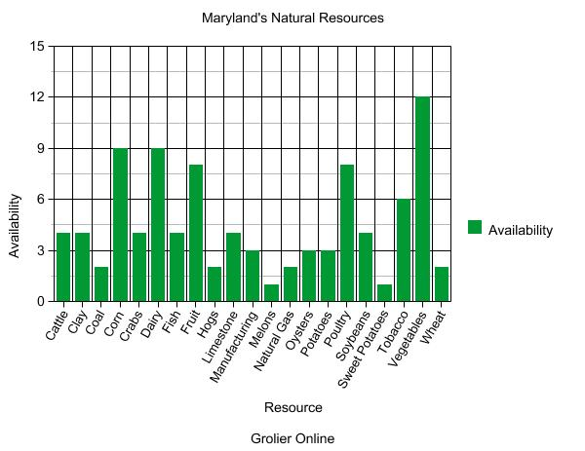

Use the graph above to answer the following questions:

1. Which renewable resource is the most abundant in Maryland?
2. Corn
3. Dairy
4. Poultry
5. Vegetables
6. Which nonrenewable resource is the most abundant in Maryland?
7. Limestone
8. Manufacturing
9. Natural Gas
10. Vegetables
11. Would Maryland be a good state to be a farmer? Why or why not? Be sure to include evidence from your graph in your reasoning.

\_\_\_\_\_\_\_\_\_\_\_\_\_\_\_\_\_\_\_\_\_\_\_\_\_\_\_\_\_\_\_\_\_\_\_\_\_\_\_\_\_\_\_\_\_\_\_\_\_\_\_\_\_\_\_\_\_\_\_\_\_\_\_\_\_\_\_\_\_\_\_\_\_\_\_\_\_\_\_\_\_\_\_\_\_\_\_\_\_\_\_\_\_\_\_\_\_\_\_\_\_\_\_\_\_\_\_\_\_\_\_\_\_\_\_\_\_\_\_\_\_\_\_\_\_\_\_\_\_\_\_\_\_\_\_\_\_\_\_\_\_\_\_\_\_\_\_\_\_\_\_\_\_\_\_\_\_\_\_\_\_\_\_\_\_\_\_\_\_\_\_\_\_\_\_\_\_\_\_\_\_\_\_\_\_\_\_\_\_\_\_\_\_\_\_\_\_\_\_\_\_\_\_\_\_\_\_\_\_\_\_\_\_\_\_\_\_\_\_\_\_\_\_\_\_\_\_\_\_\_\_\_\_\_\_\_\_\_\_\_\_\_\_\_\_\_\_\_\_\_\_\_\_\_\_\_\_\_\_\_\_\_\_\_\_\_\_\_\_\_\_\_\_\_\_\_\_\_\_\_\_\_\_\_\_\_\_\_\_\_\_\_\_\_\_\_\_\_\_\_\_\_\_\_\_\_\_\_\_\_\_\_\_\_\_\_\_\_\_\_\_\_\_\_\_\_\_\_\_\_\_\_\_\_\_\_\_\_\_\_\_\_\_\_\_\_\_\_\_\_\_\_\_\_\_\_\_\_\_\_\_\_\_\_\_\_\_\_\_\_\_\_\_\_\_\_\_\_\_\_\_\_\_\_\_\_\_\_\_\_\_\_\_\_\_\_\_\_\_\_\_\_\_\_\_\_\_\_\_\_\_\_\_\_\_\_\_\_\_\_\_\_\_\_\_\_\_\_\_\_\_\_\_\_\_\_\_\_\_\_\_\_\_\_\_\_\_\_\_\_\_\_\_\_\_\_\_\_\_\_\_\_\_\_\_\_\_\_\_\_\_\_\_\_\_\_\_\_\_\_\_\_\_\_\_\_\_\_\_\_\_\_\_\_\_\_\_\_\_\_\_\_\_\_\_\_\_\_\_\_\_\_\_\_\_\_\_\_\_\_

**Teacher’s Key**

###### **Maryland’s Resources**

1. D
2. A
3. B
4. D
5. C
6. D
7. A
8. Would Maryland be a good state to be a farmer? Why or why not? Be sure to include evidence from your map and graph in your reasoning.

\_\_\_\_***Maryland would be a great place to be a farmer for several reasons. First, according to the key on the map, most of Maryland is farm land. Second, there are many renewable resources in Maryland that are grown and harvested such as corn, tobacco, and soybeans. According to the graph, vegetables are the most available renewable resource in Maryland and therefore being a farmer would be a great job to have. Farming however, is not necessarily just growing plants. Farming can include raising cattle, hogs and poultry. All of which are renewable resources found in Maryland. Being a farmer in Maryland would be a worthwhile occupation and would give anyone many options to what type of farmer they would want to be. \_\_\_\_\_\_\_\_\_\_\_\_\_\_\_\_\_\_\_\_\_\_\_\_\_\_\_\_\_\_\_\_\_\_\_\_\_\_\_\_***